**General changes**

Main pages could have 2 images per page, one at the top banner and one at the bottom banner (call to action banner).

Aesthetics change: Button layout should be either aligned to the left (all buttons on the same line) or all buttons except for the ones at the initial banner to be centered.

**Debugging:** Links at nested pages need to be checked, some are saved on the main link instead of nested as they should be. Some overview sections are small at the end.

**Example:**

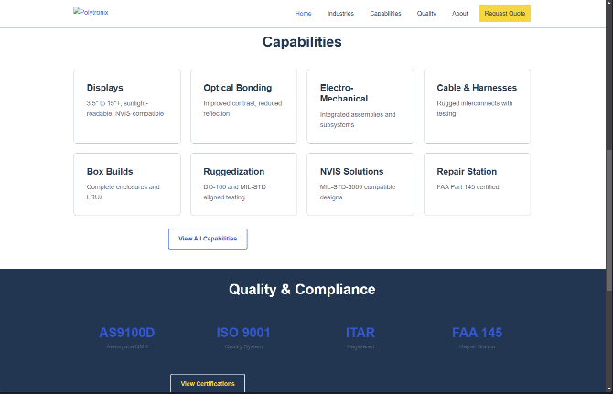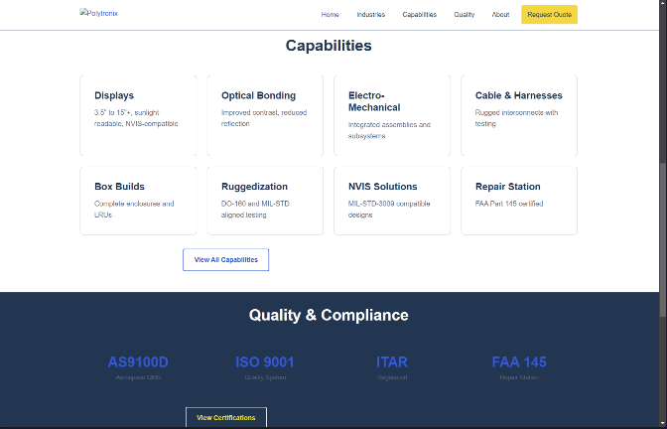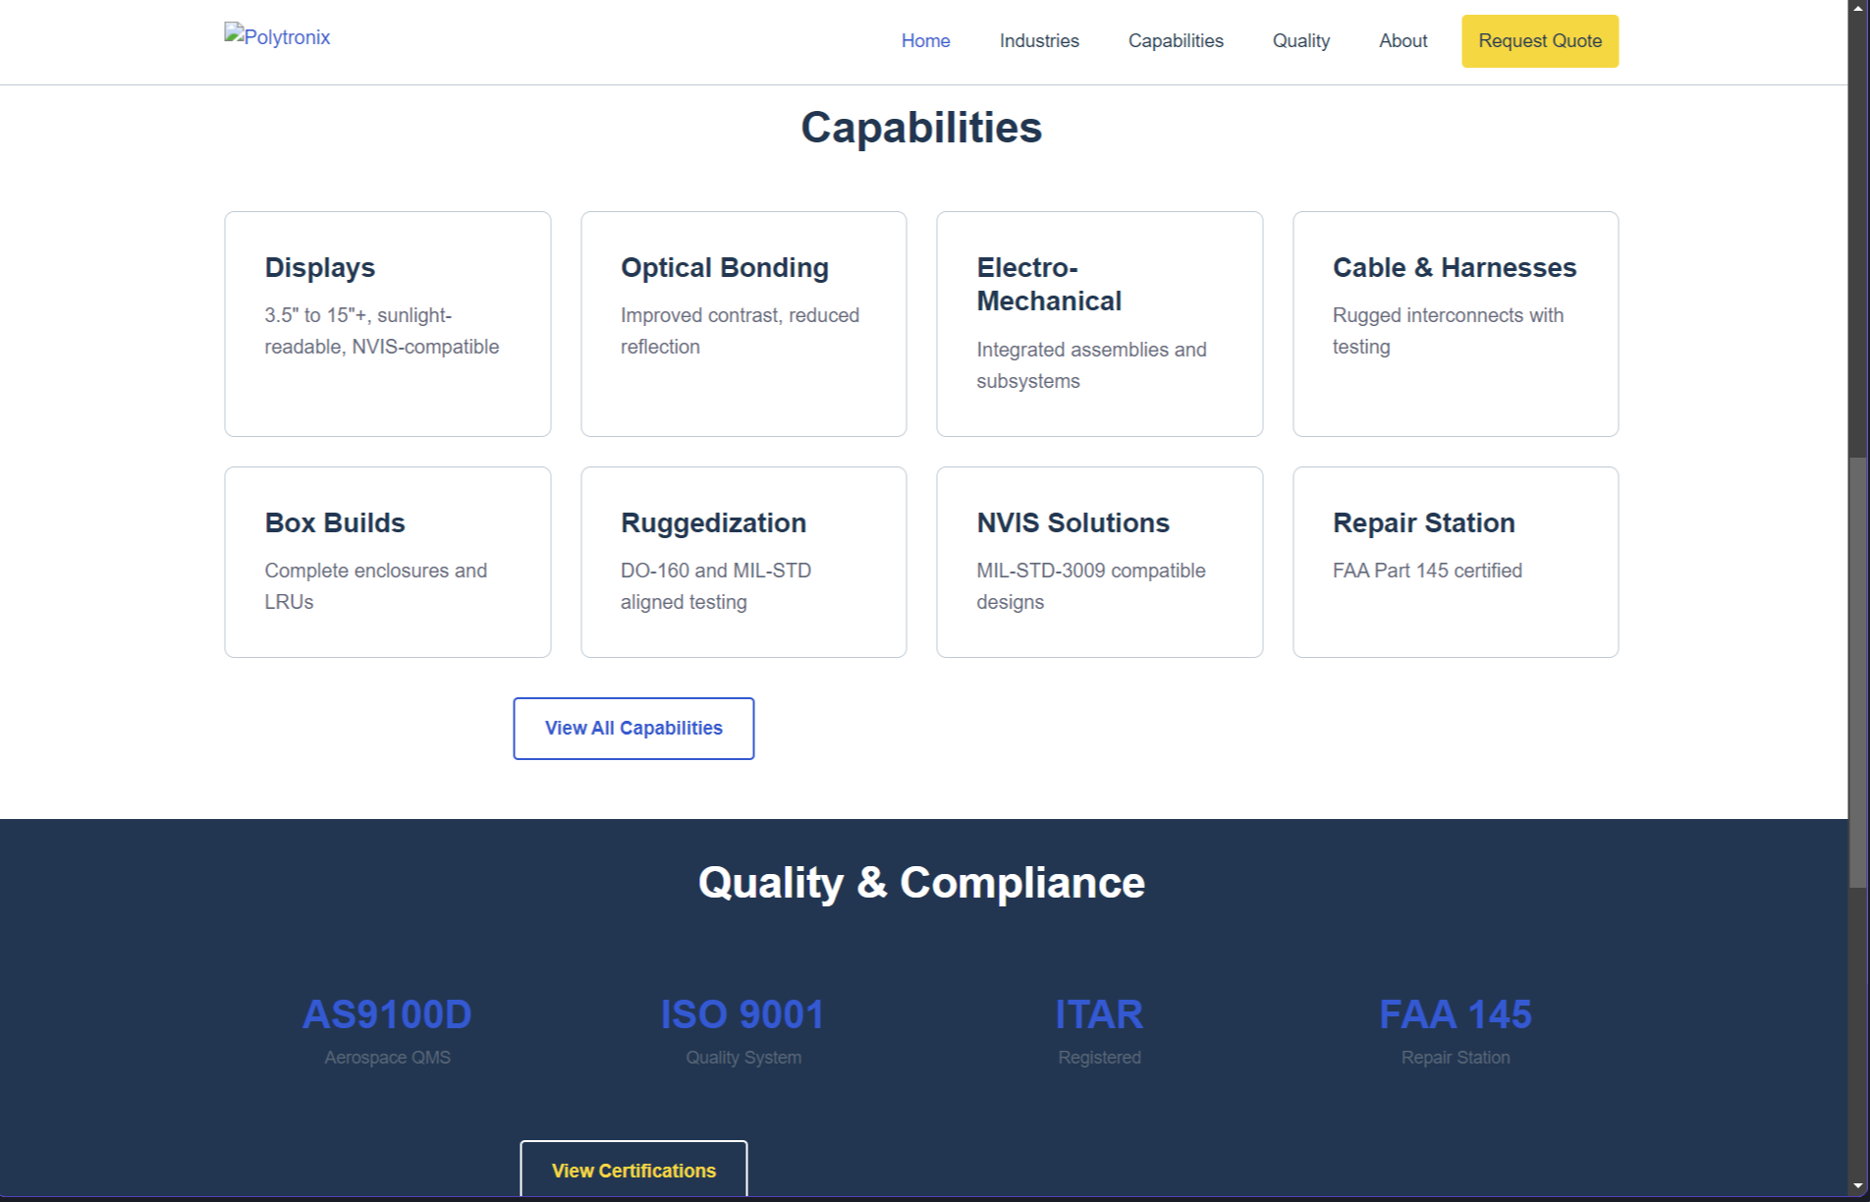

**Instead of:**



**Index.html (HOMEPAGE)**

**Changes:**

1. Debugging: Rename Index to Homepage.
2. Top banner image:

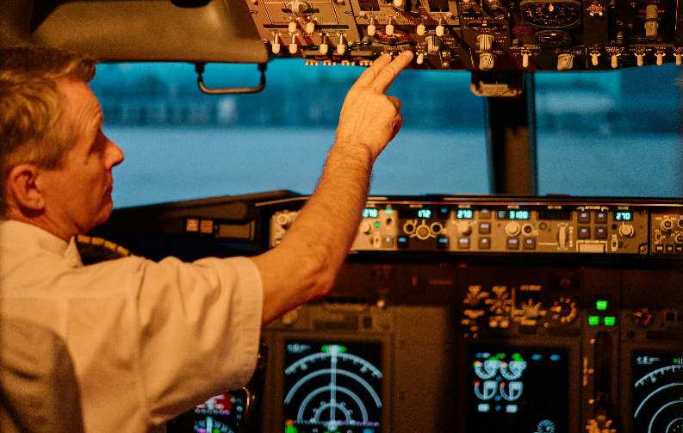

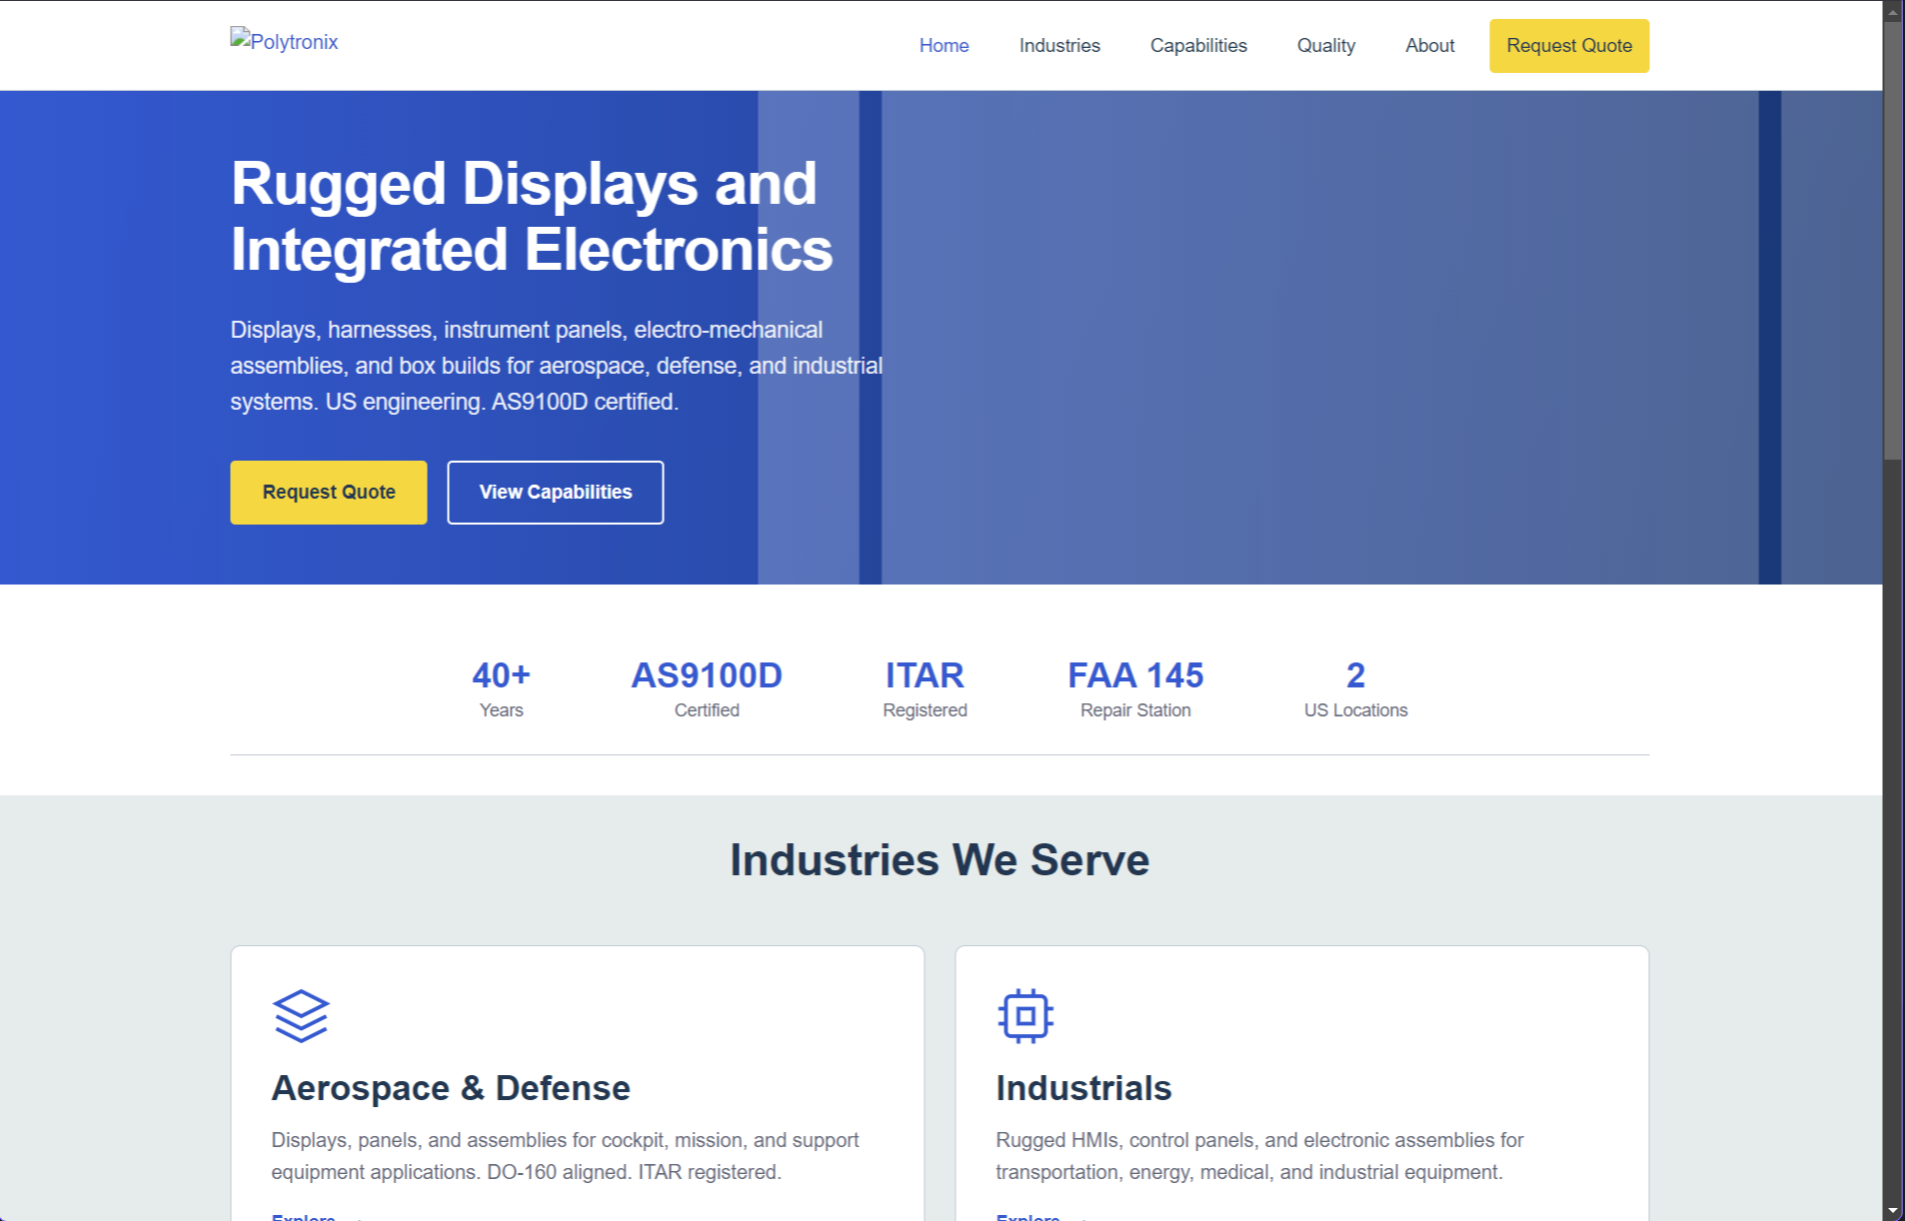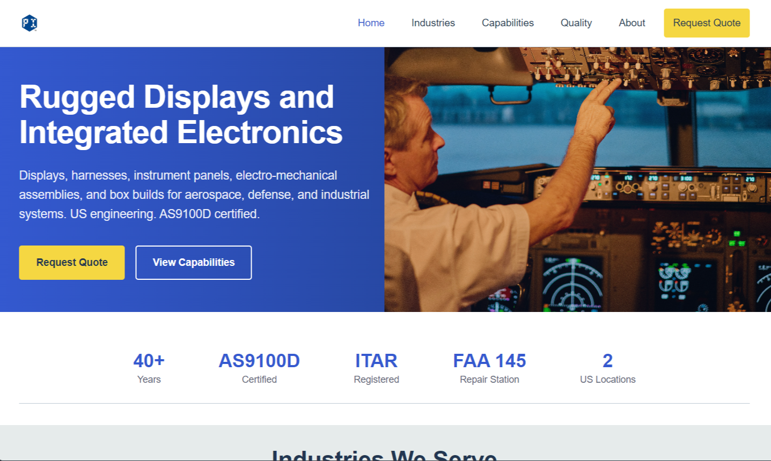

**about.html (ABOUT)**

Blue zone could have a background image (optional)

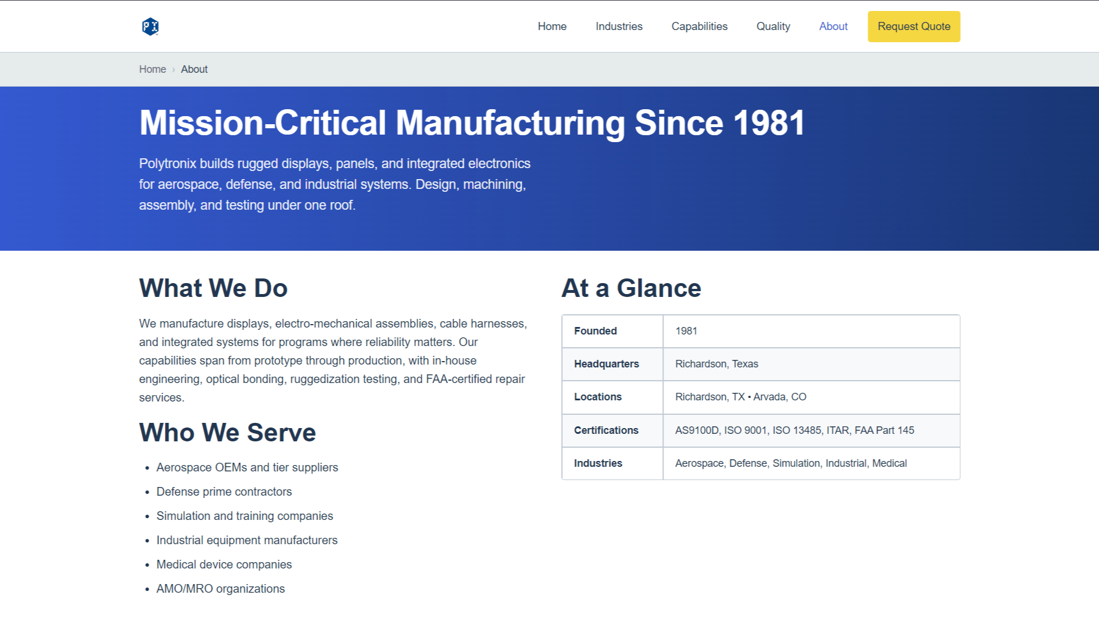

**capabilities.html**

Blue zone could have a background image (optional).

Leave gray areas and everything else as it is.

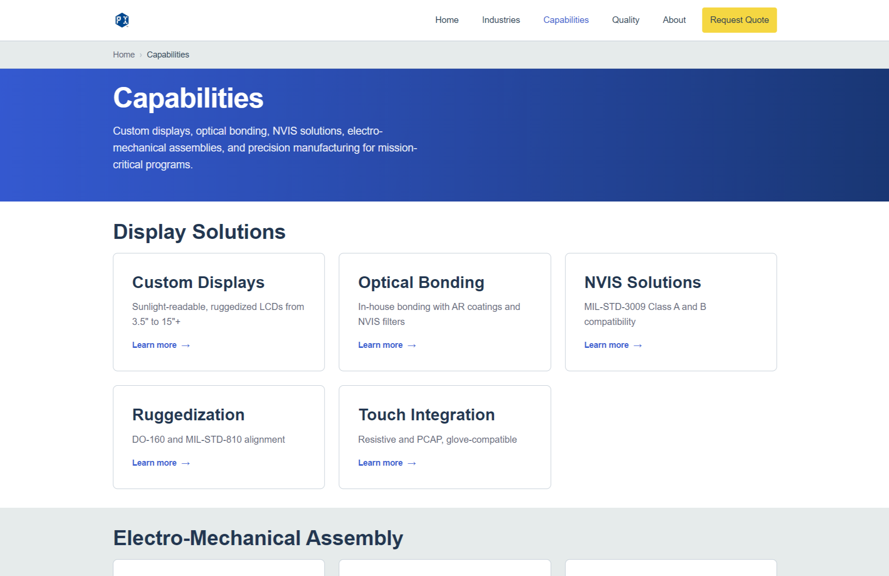

**certifications.html (Quality)**

Blue zone could have a background image (optional)

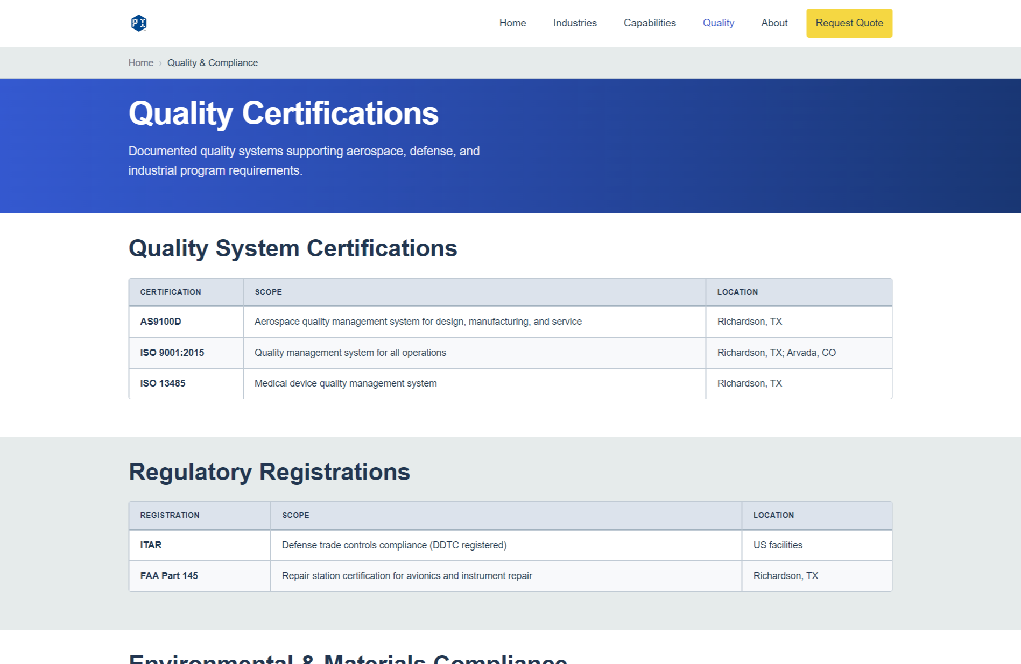

**industries.html**

Same with blue top banner.

Links should be fixed here, changed to the proper addresses on each button:

Eg. /industries/aerospace-defense.html

Eg. /industries/industrials.html

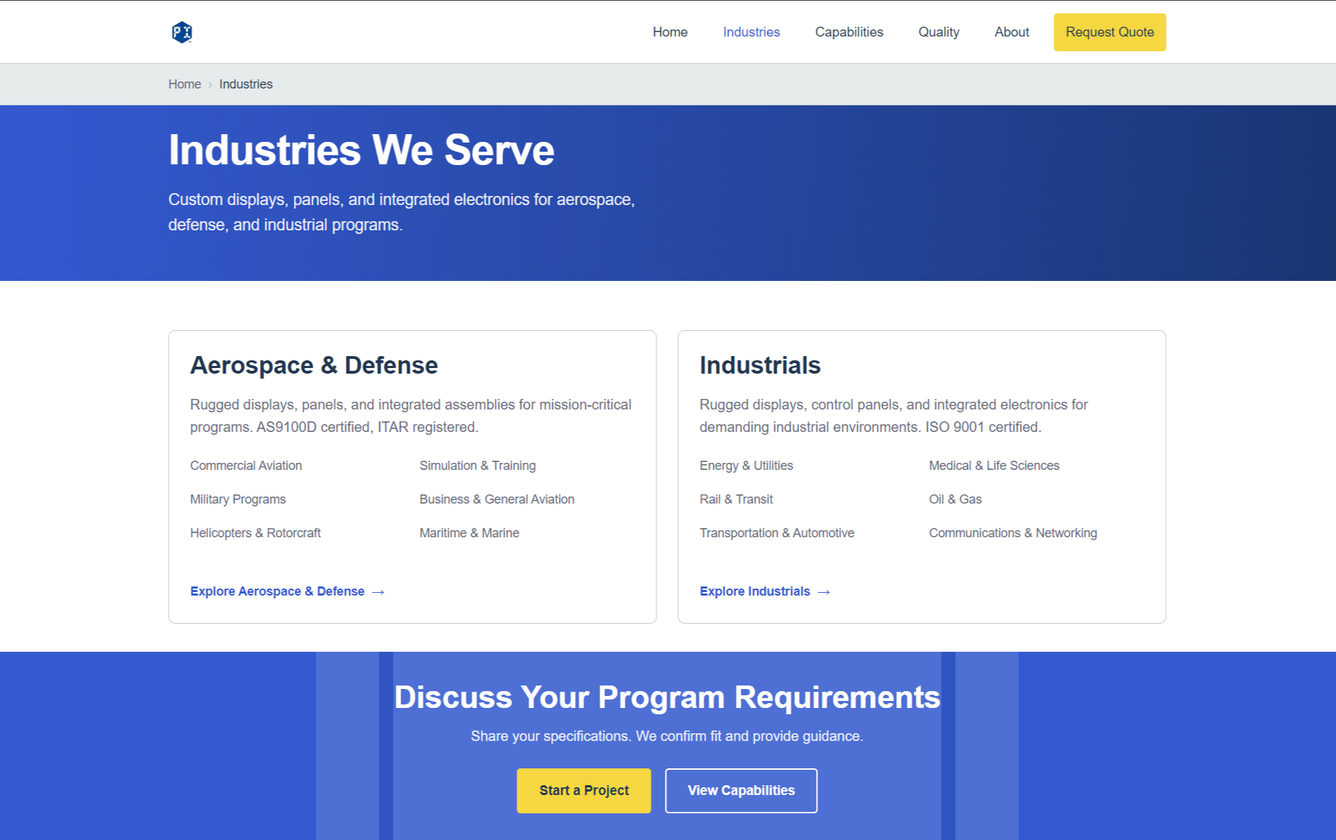

**contact.html**

Top banner with background image (optional)

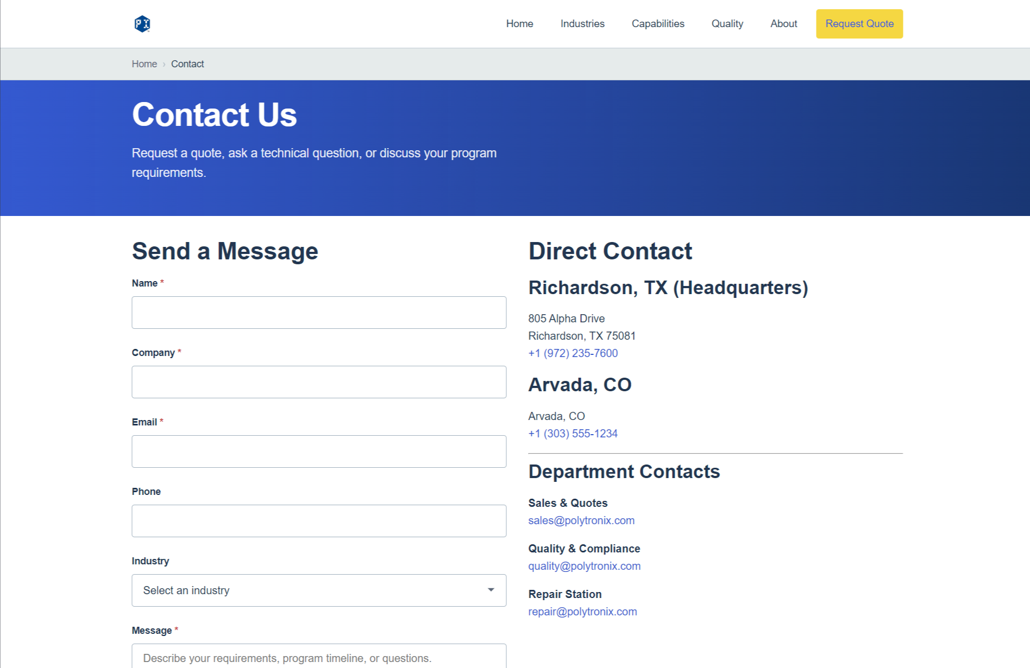

**aerospace-defense.html**

**Debugging:** Fix link to industries/aerospace-defense

**Test idea:** Instead of having the image (image coming soon) would add it in a banner format.

Light grey background of the “AT GLANCE” table must be fixed because it is hard to read. Also this table is redundant with a bottom table, can be left twice on purpose, or bottom one could be moved up to have a greater importance. This is applicable to all remaining pages.

Request a quote and Speak to engineering leads to same Contact page, 40+ years supporting high-reliability aerospace and defense programs is duplicated.

**Suggestion:** remove the image and leave as background image (entire banner), move table to where image is, remove speak to engineering button with the 40+ years message. This is applicable to all remaining pages.

**Image for placeholder:**

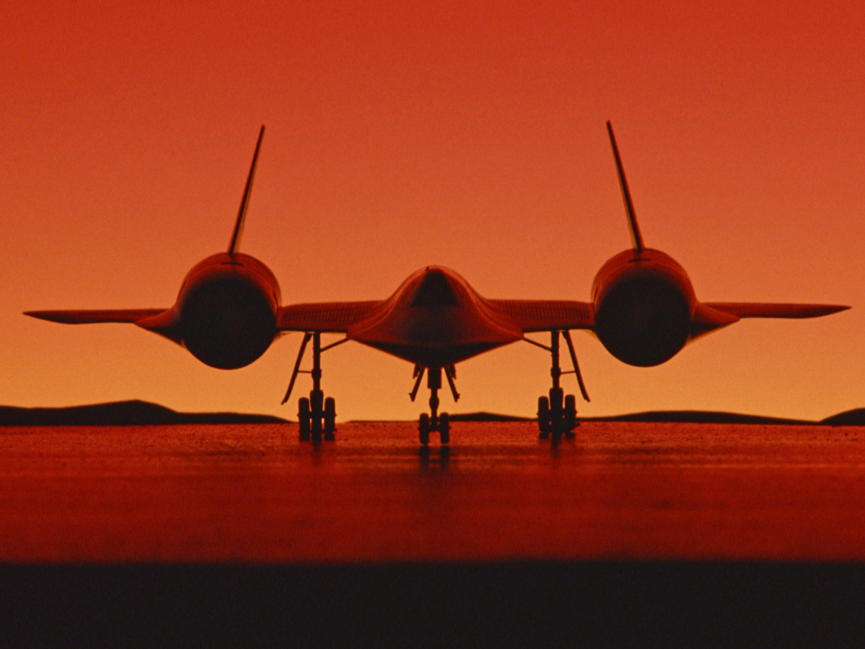

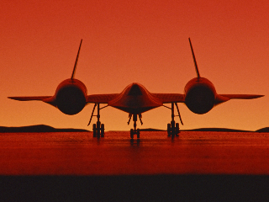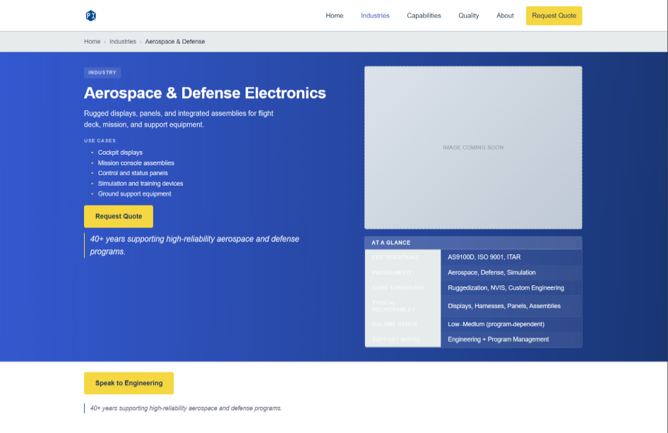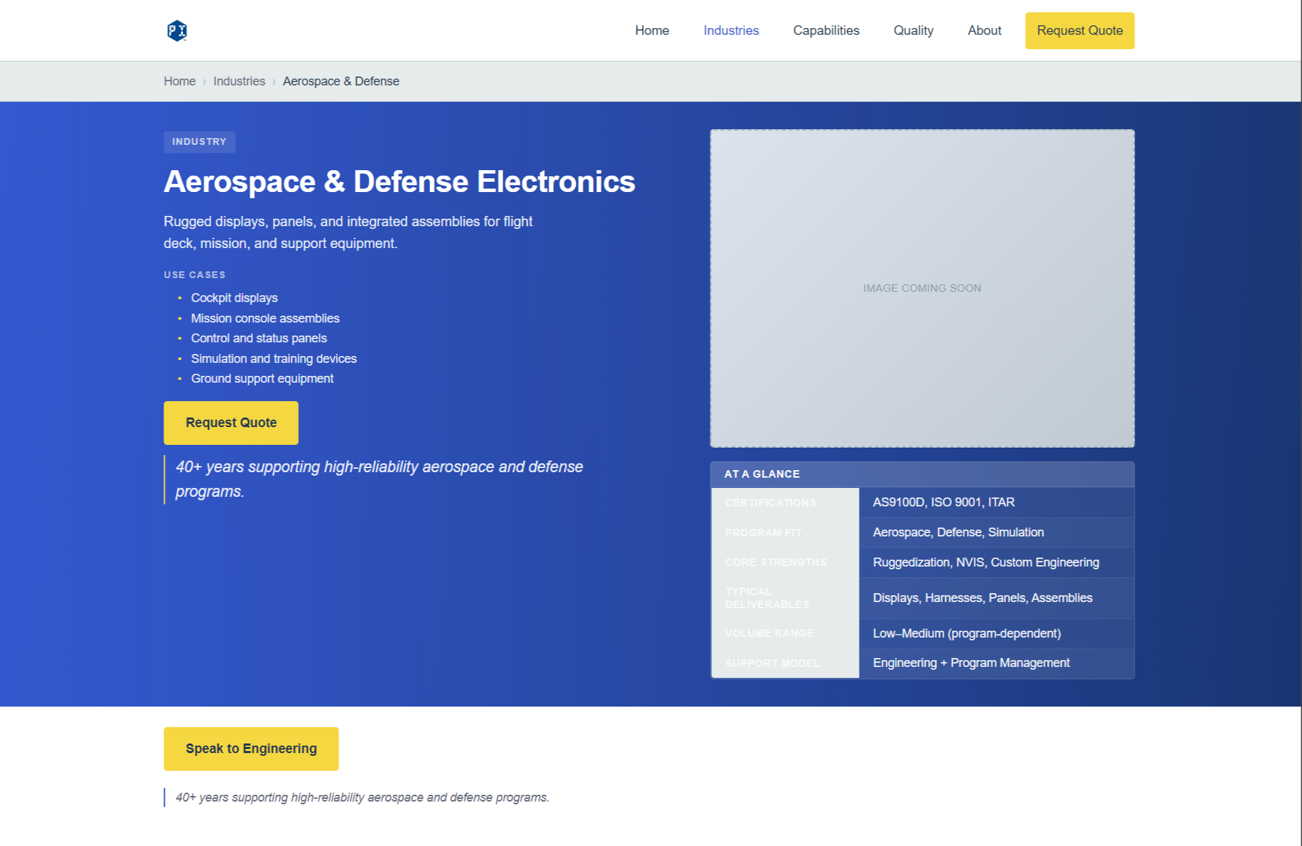



**industrials.html**

Link must be fixed to industries/industrials

**Placeholder Image:**

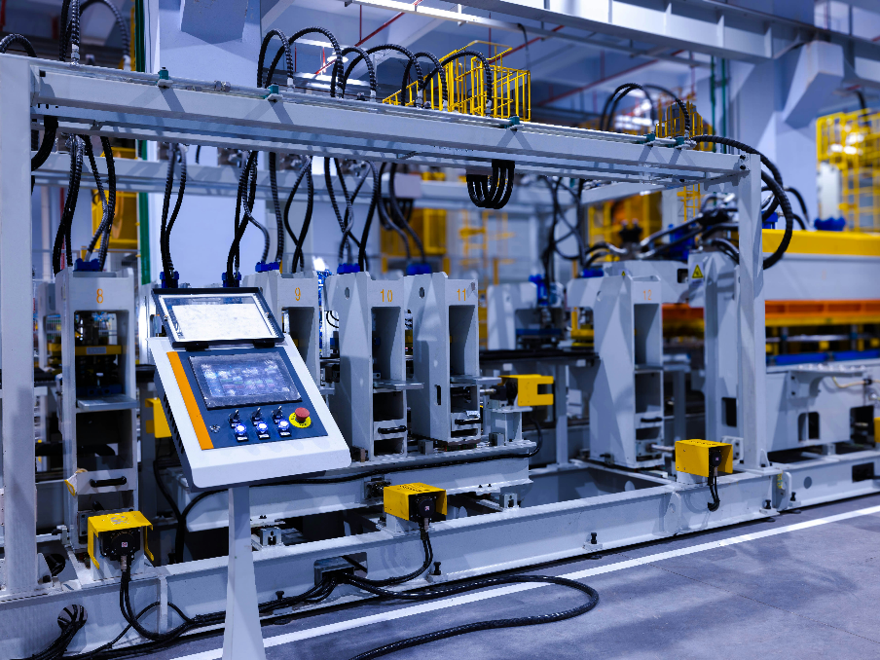

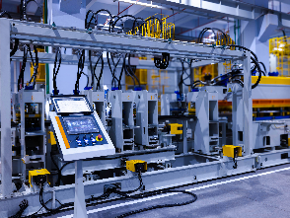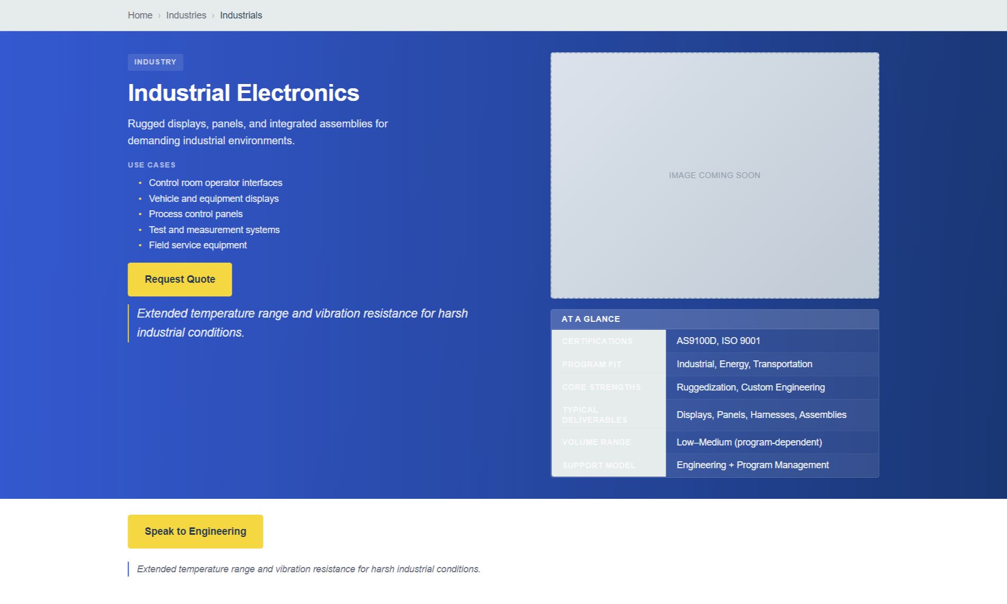



**commercial-aviation.html**

Debugging:

Link is broken at Aerospace and Defense Electronics: working button is commercial-aviation.html should be /industries/aerospace-defense/commercial-aviation.html. Fix overview section which is small at the end.

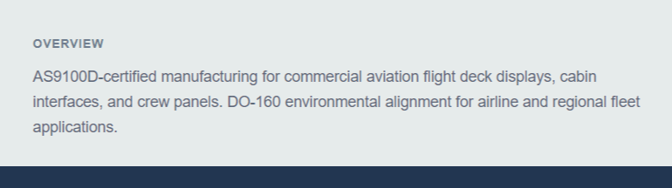

**Placeholder image:**

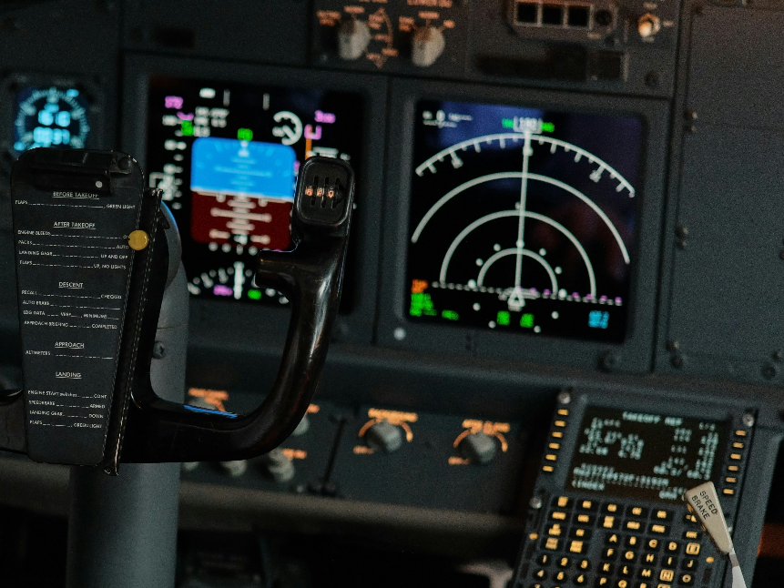

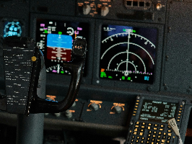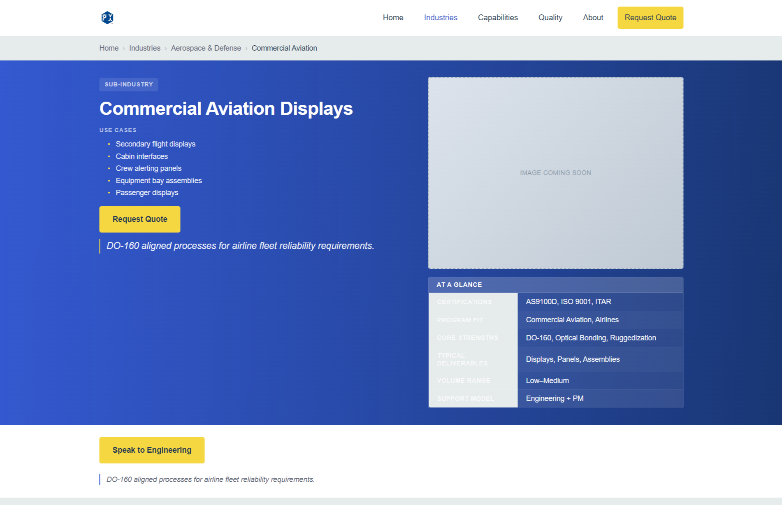



**business-aviation.html**

**Debugging:** Link should be /industries/aerospace-defense/business-general-aviation

Certifications can remain as they are, iso buttons looks nice at the bottom. Fix overview section which is small at the end.



**Placeholder image:**

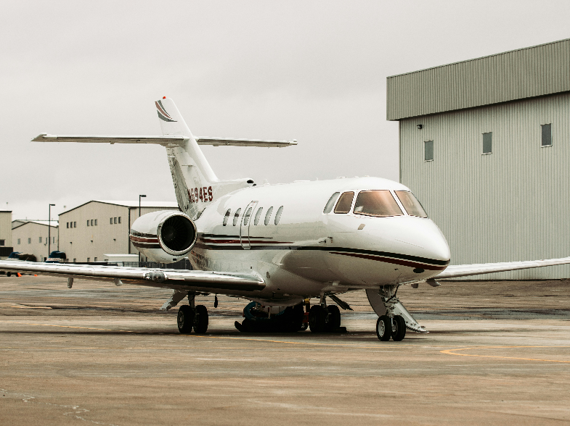

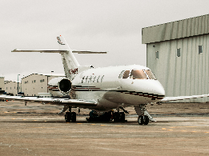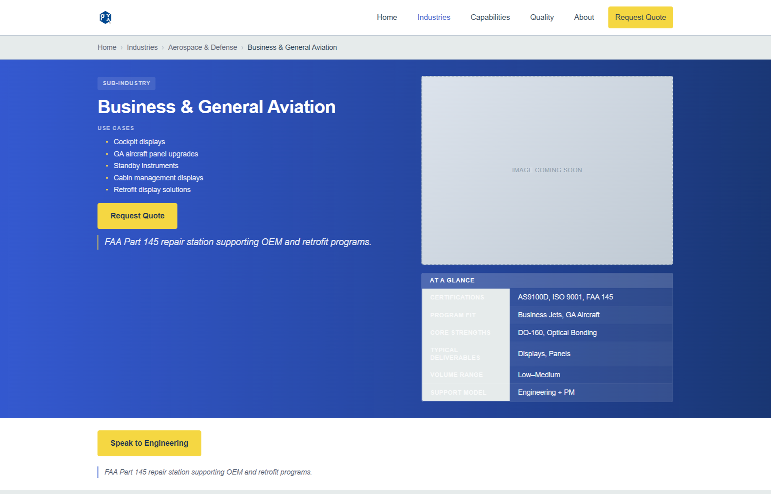



**military-programs.html**

**Debugging:** Fix link to /industries/aerospace-defense/military-programs

Fix overview section which is small at the end.

**Placeholder image:**

Could be changed for the interior of an armored vehicle or similar if possible. Couldn’t find any better options.

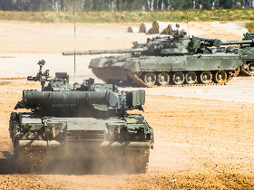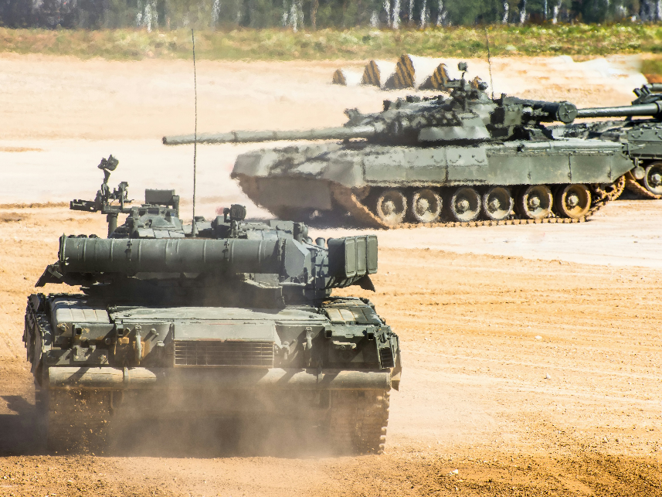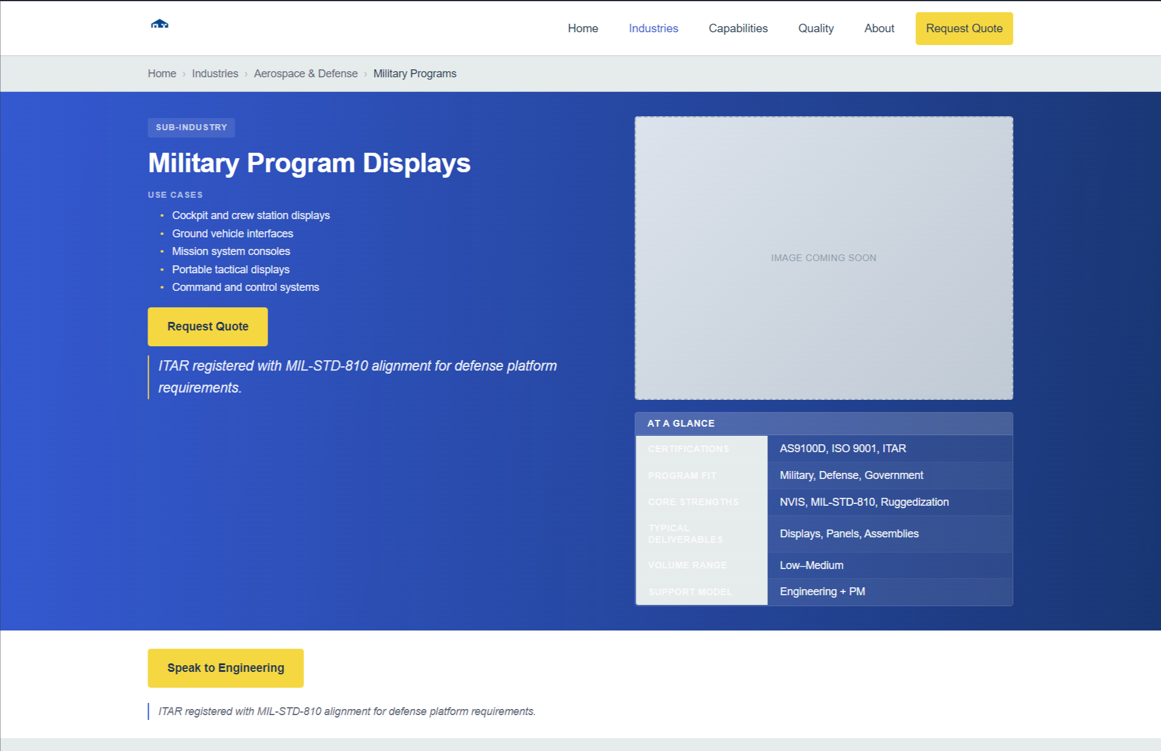

**helicopters.html**

**Debugging:** link should be /industries/aerospace-defense/helicopters. Fix overview section which is small at the end.

**Placeholder image:**

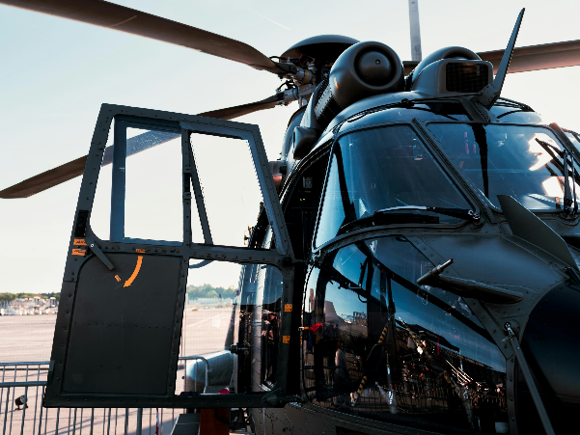

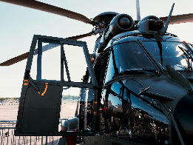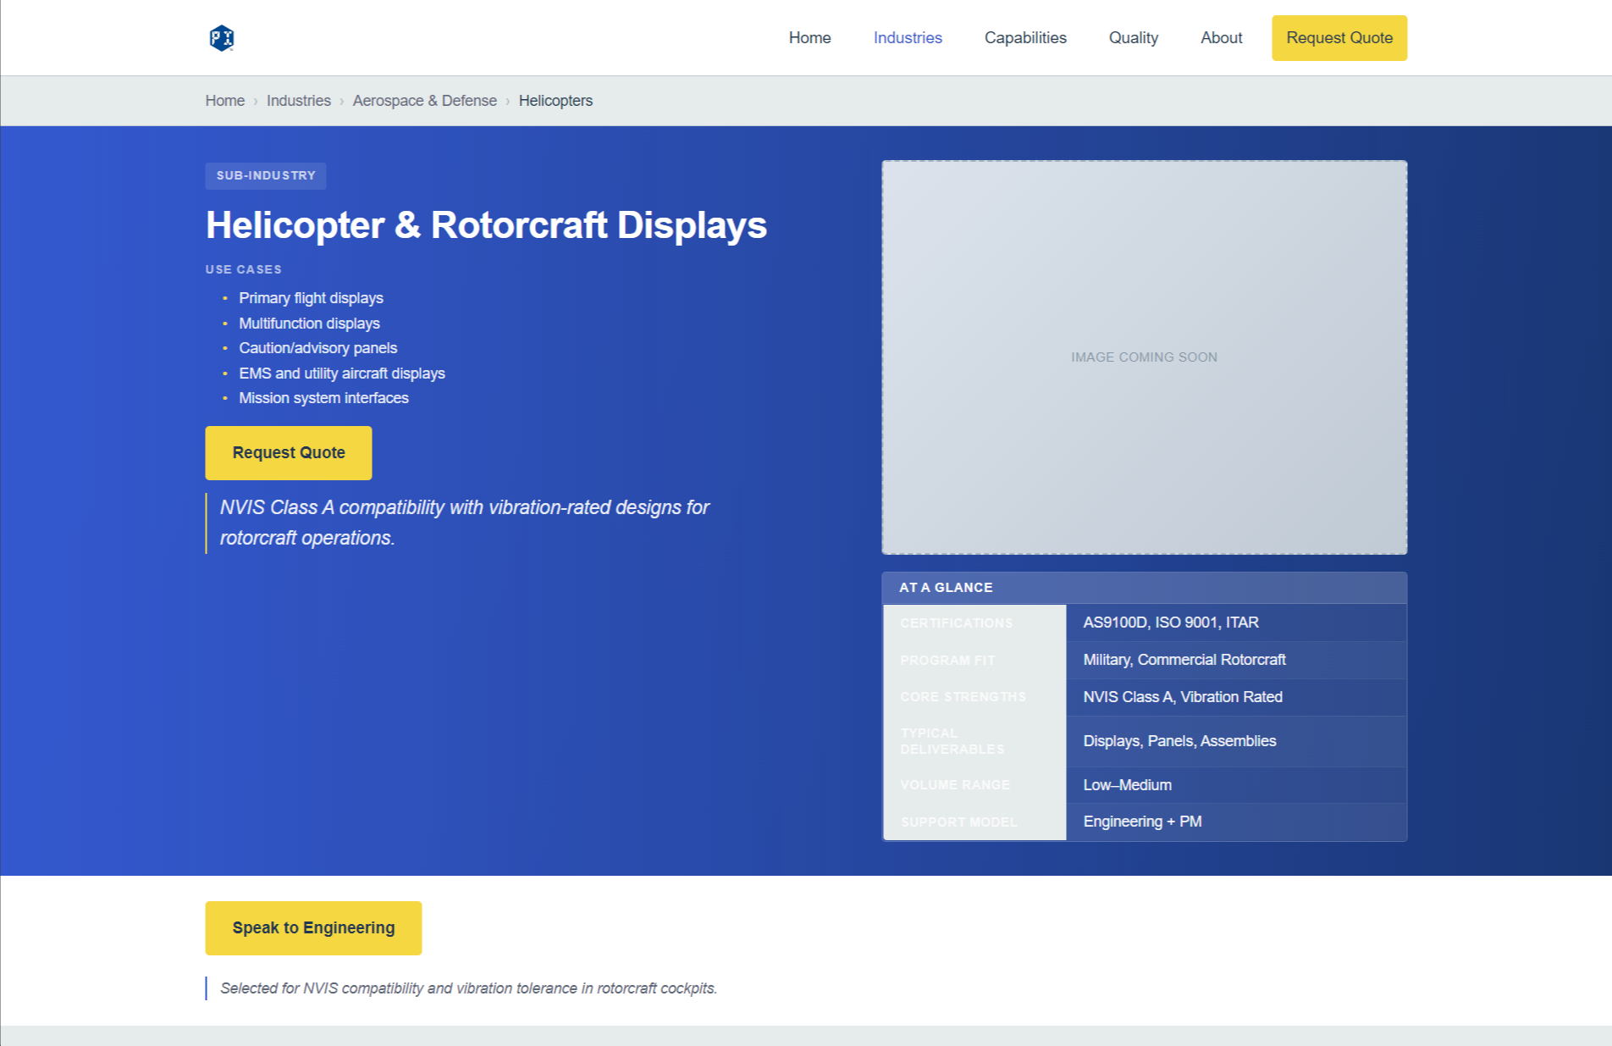



**simulation-training.html**

**Debugging:** link should be /industries/aerospace-defense/simulation-training

Fix overview section which is small at the end. 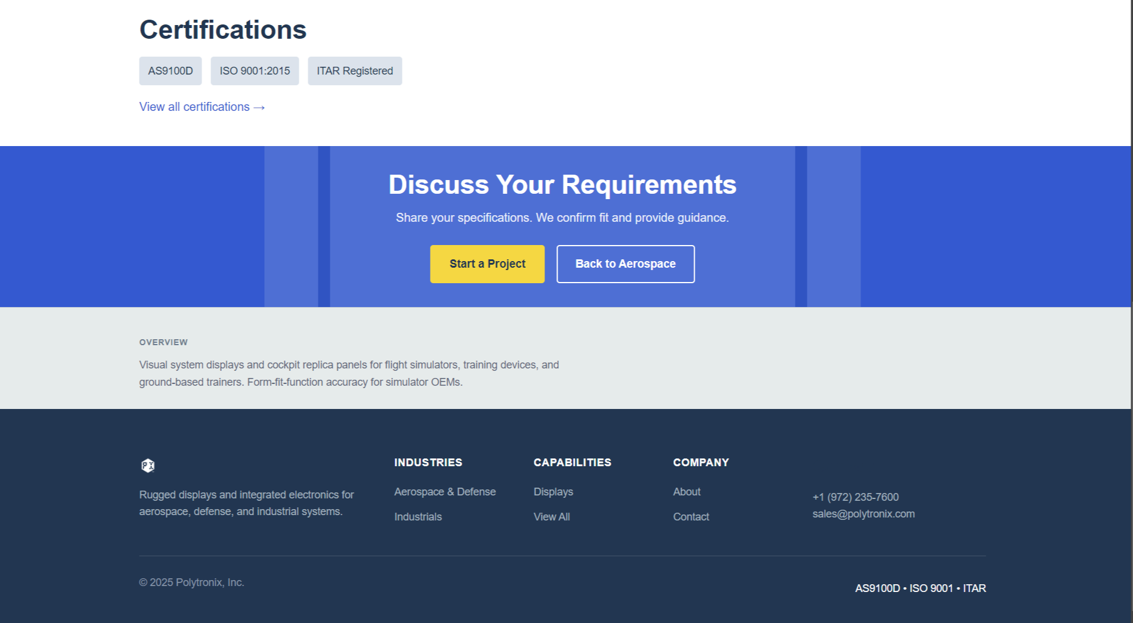

**Placeholder image:**

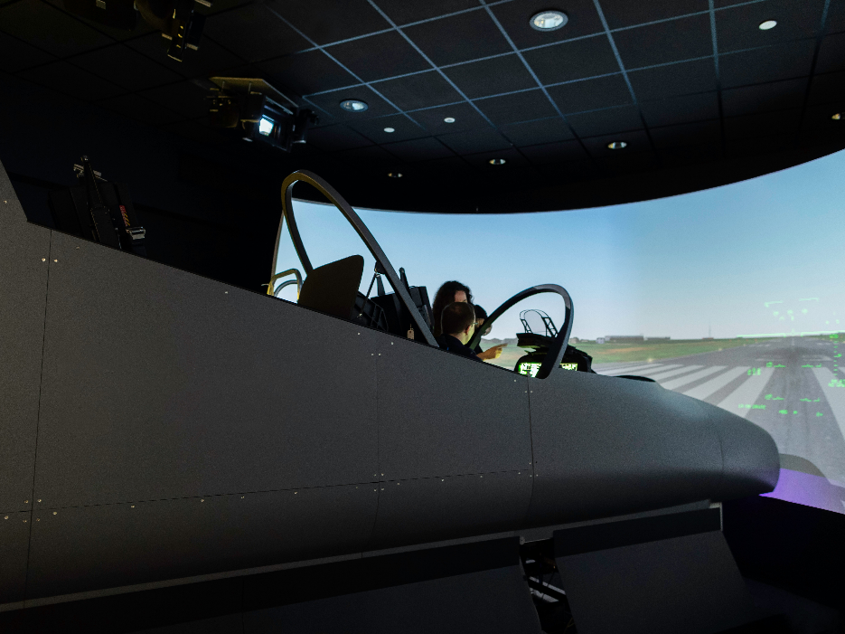

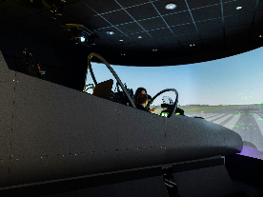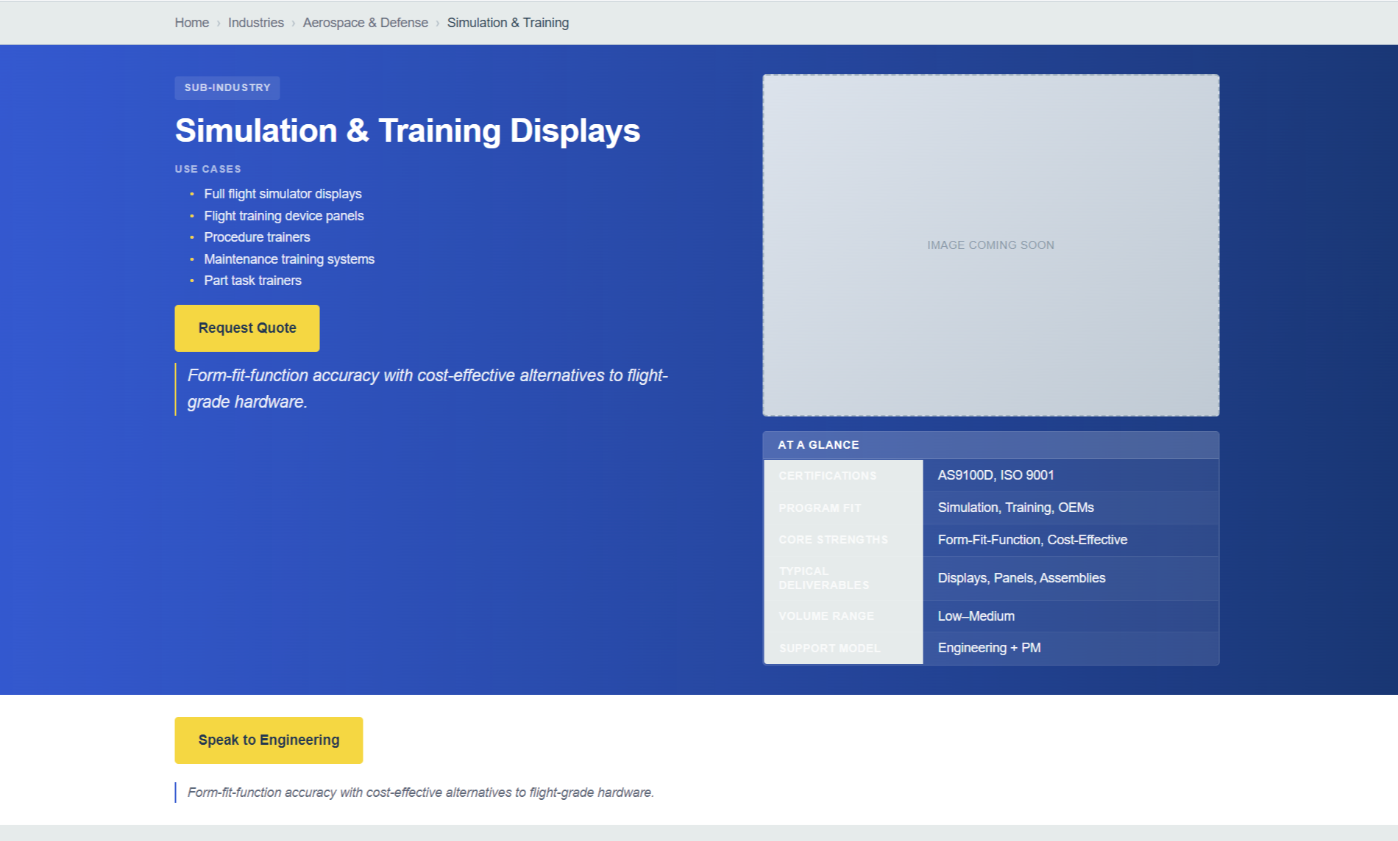



**maritime-marine.html**

**Debugging:** Link should be /industries/aerospace-defense/maritime-marine Fix overview

**Placeholder image:**

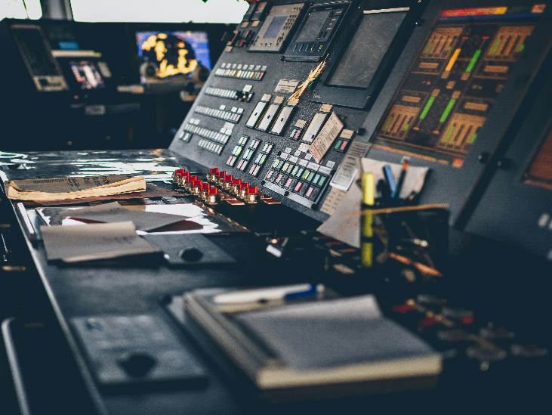

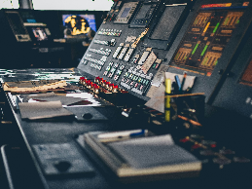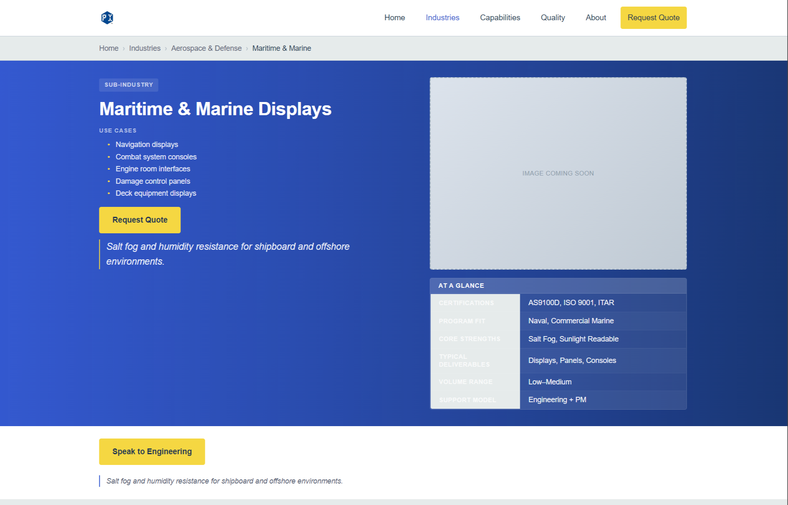



**rail-transit.html**

**Debugging:** Link should be /industries/industrials/rail-transit Fix overview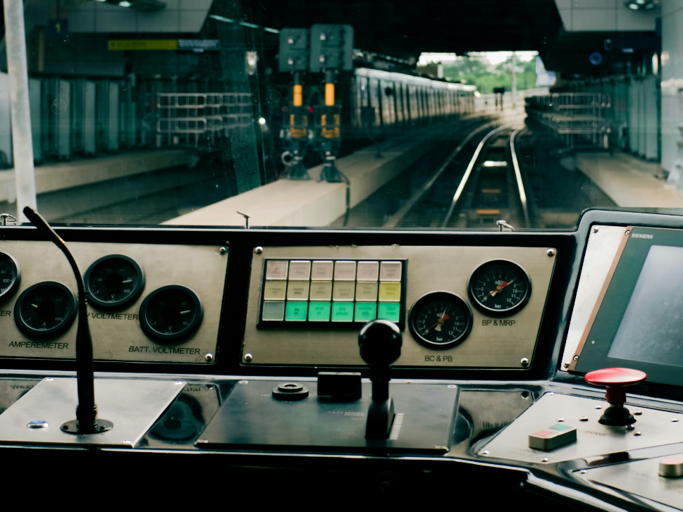

**Option 2:**



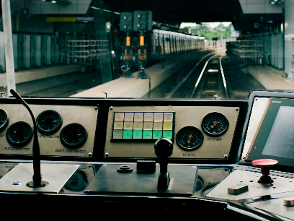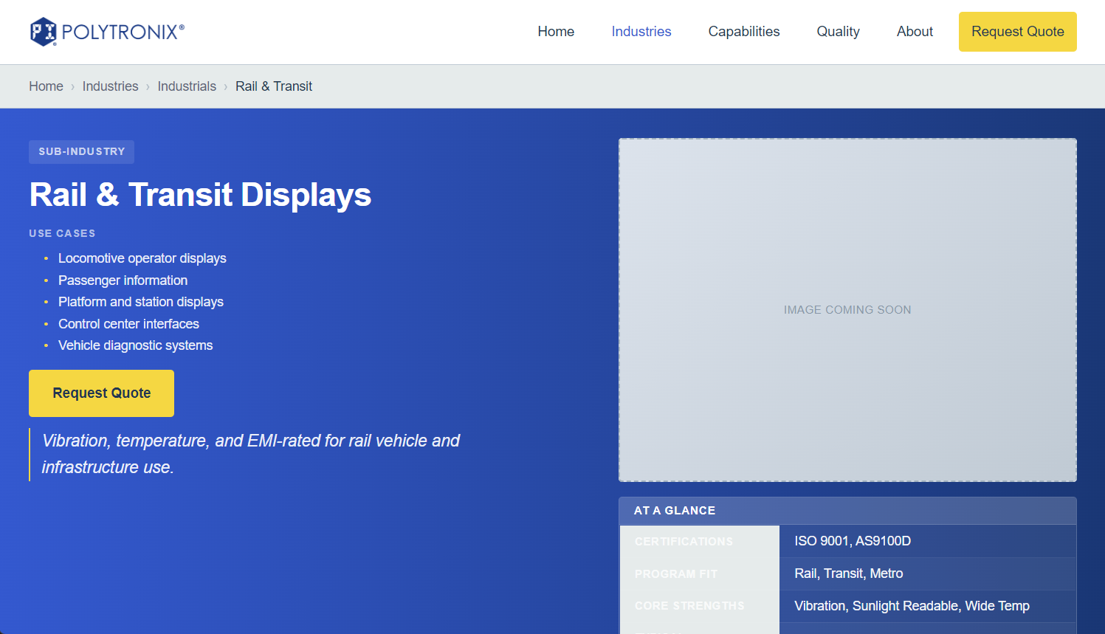

**oil-gas.html**

**Debugging:** Link should be /industries/industrials/oil-gas Fix overview

**Placeholder image:**

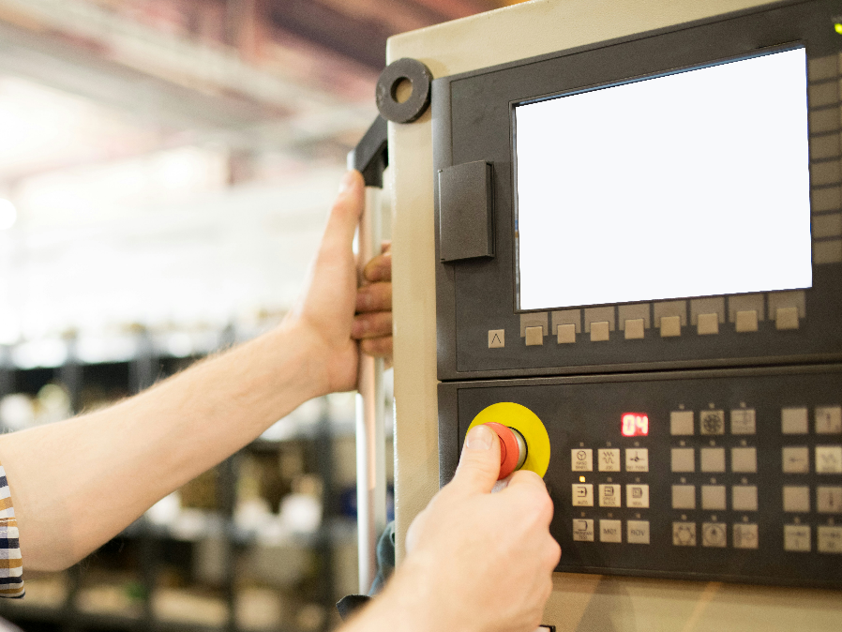

**Option 2:**

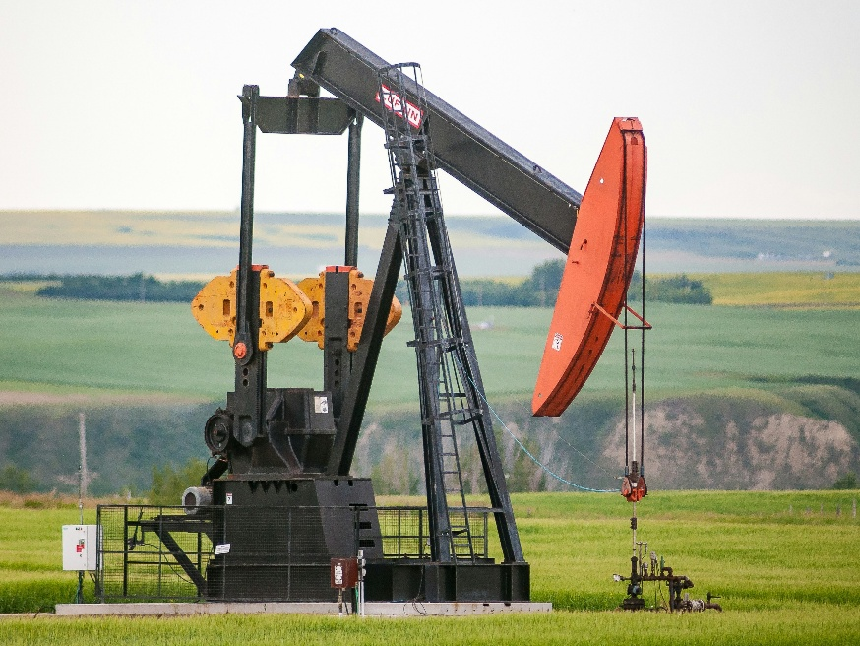

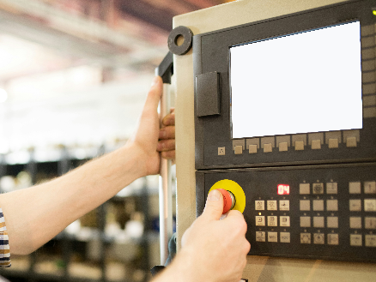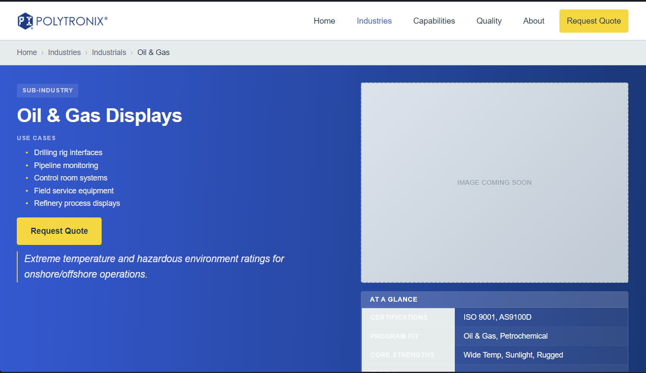

**medical-life-sciences.html**

**Debugging:** Link should be /industries/industrials/medical-life-sciences Fix overview

**Placeholder image:**

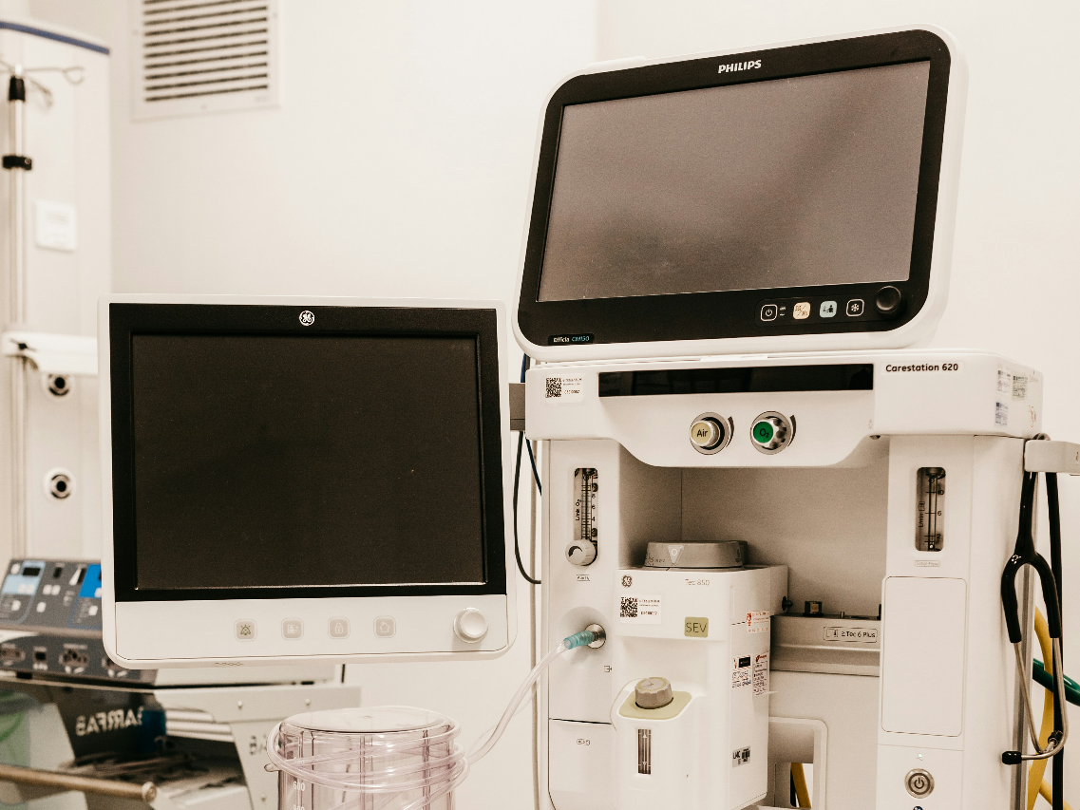

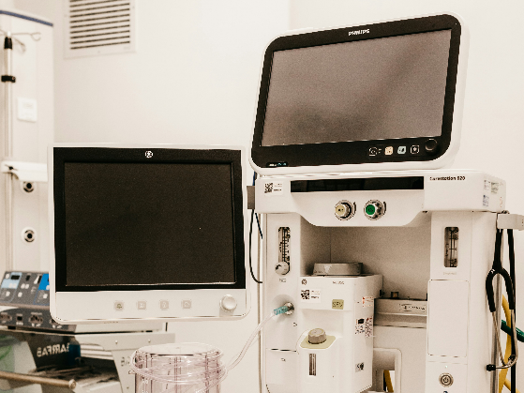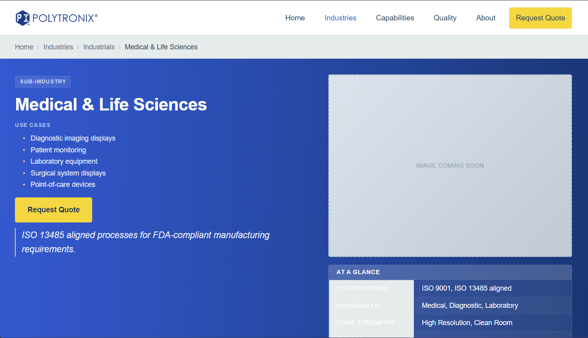

**communications-networking.html**

**Debugging:** Link should be /industries/industrials/communications-networking

Fix overview.

**Placeholder image:**

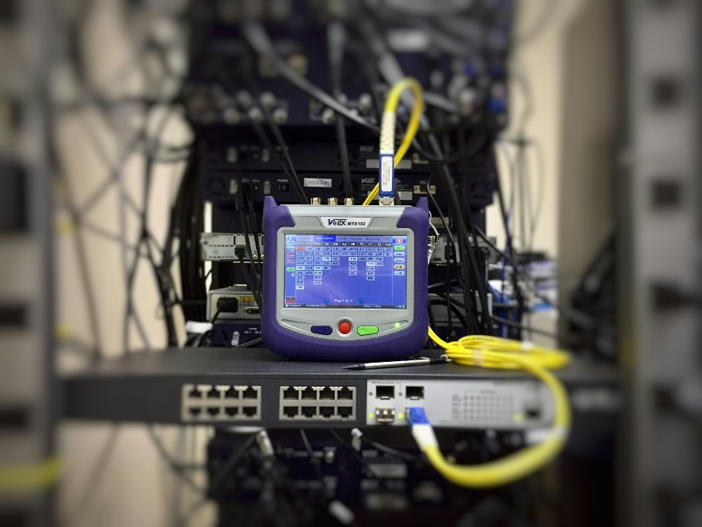

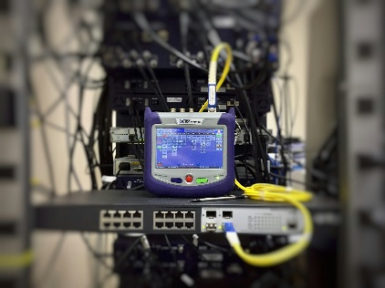 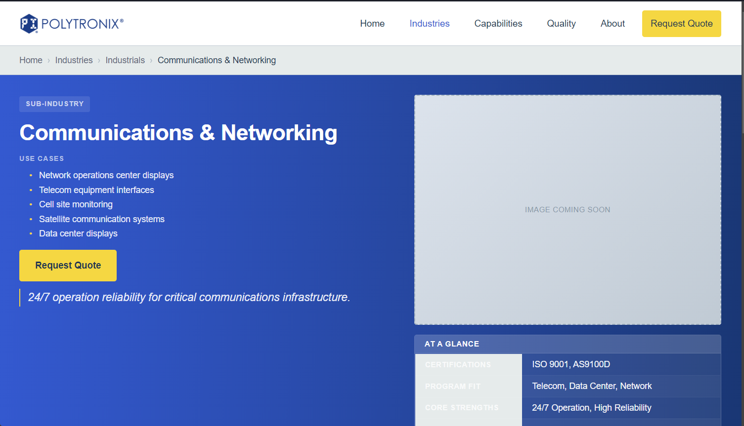

**energy-utilities.html**

**Debugging:** Link should be /industries/industrials/energy-utilities Fix overview

**Placeholder image:**

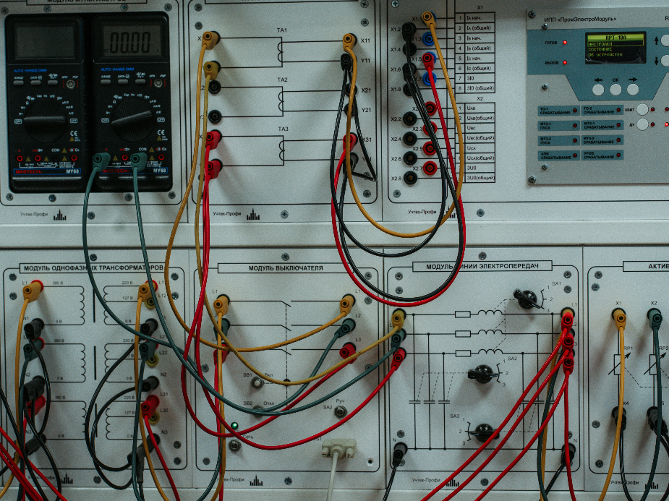

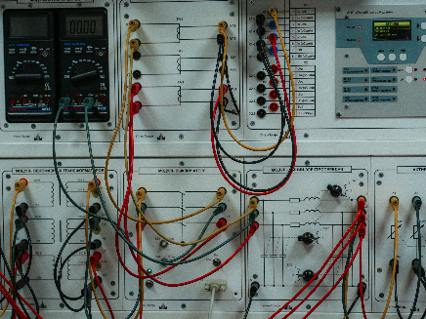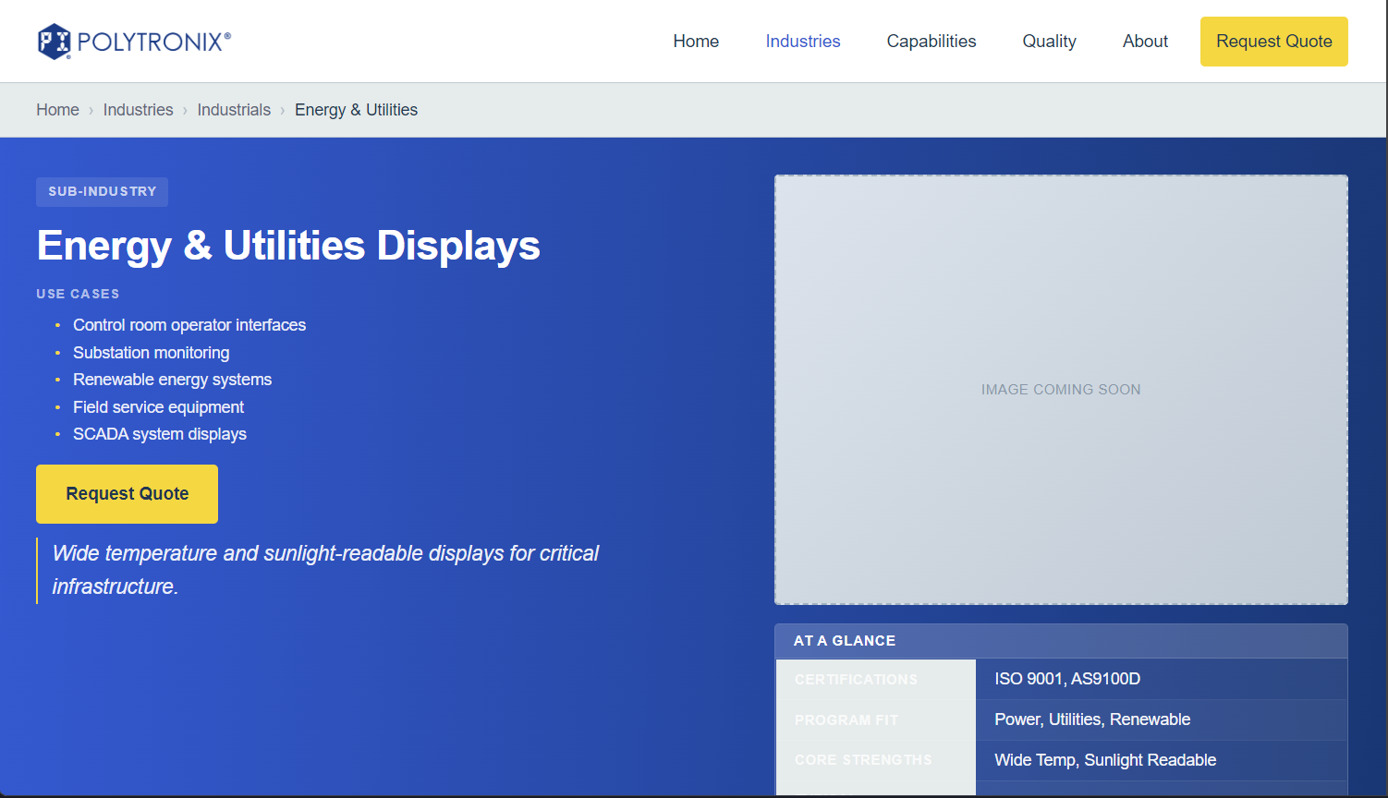

**industrial-equipment.html**

**Debugging:** Link should be /industries/industrials/industrial-equipment

Fix overview, no button to get there anywhere, add it in Industries or eliminate page.

**Placeholder image:**

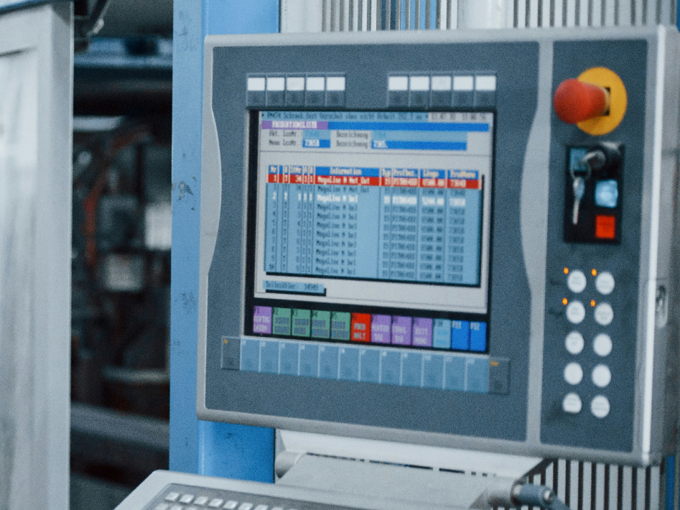

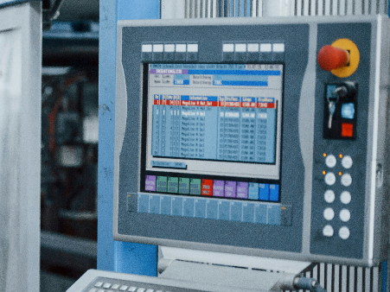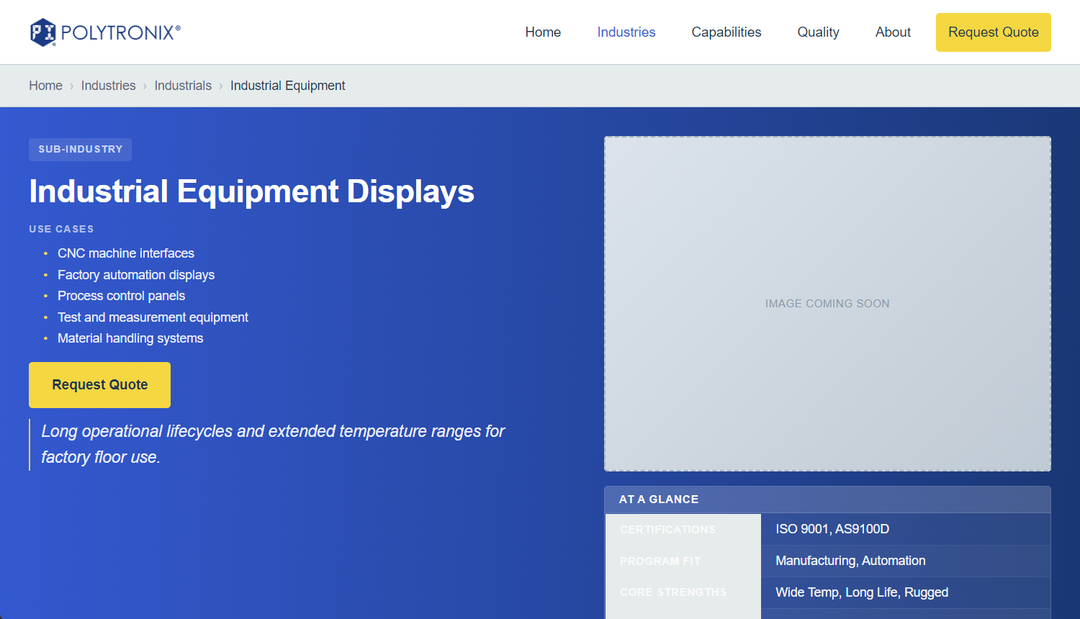

**transportation-automotive.html**

**Debugging:** Link should be /industries/industrials/transportation-automotive Fix overview

**Placeholder image:**

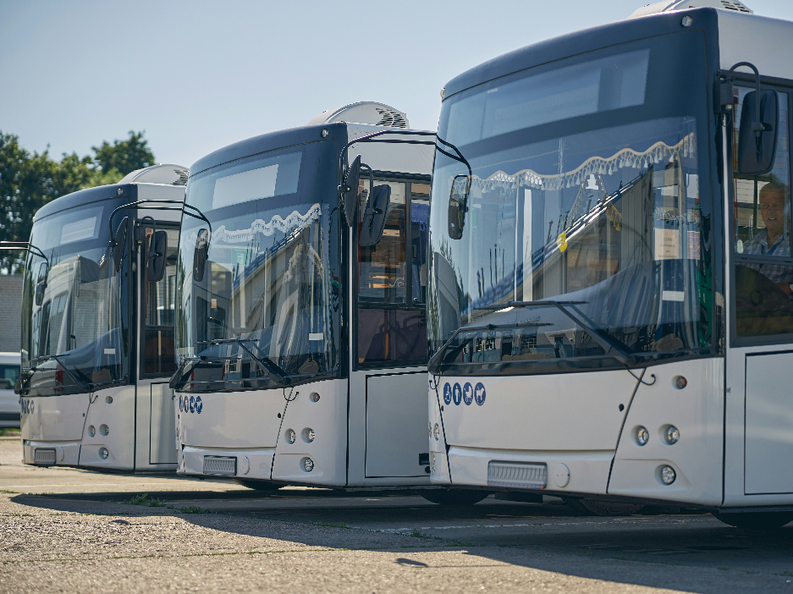

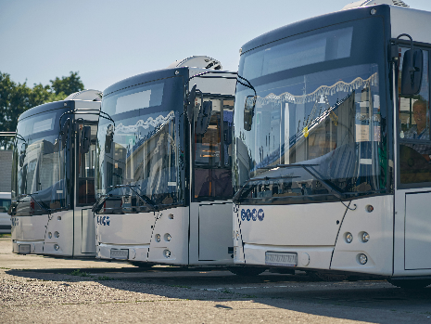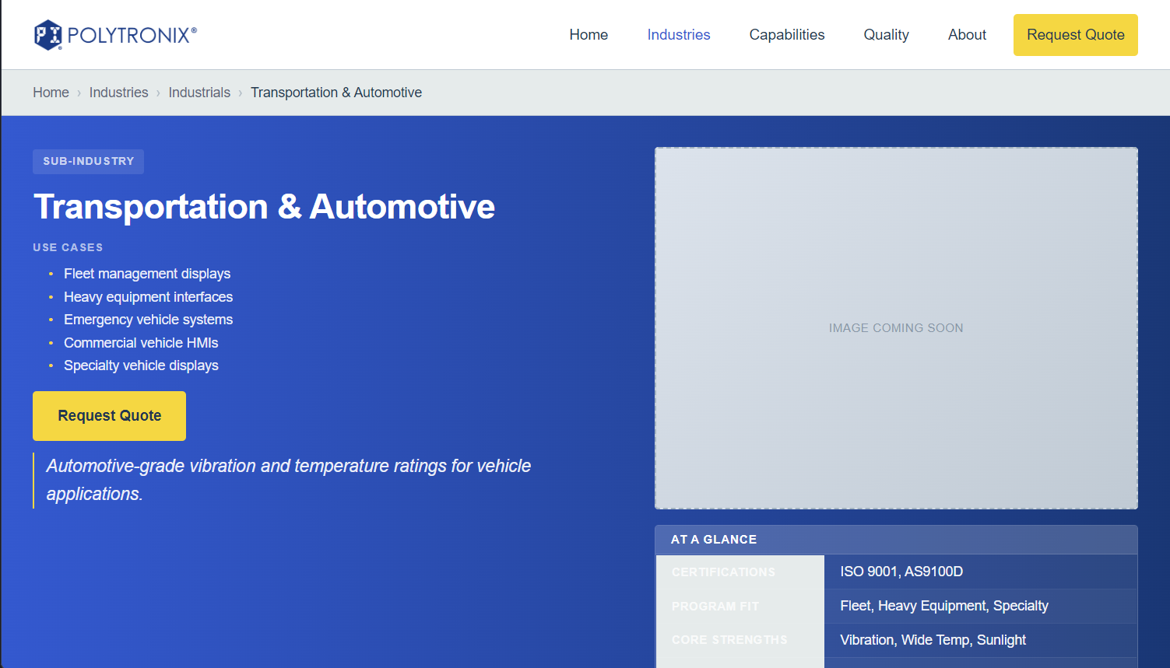

**displays.html**

**Debugging:** Link should be capabilities/displays Fix overview

**Placeholder image:**

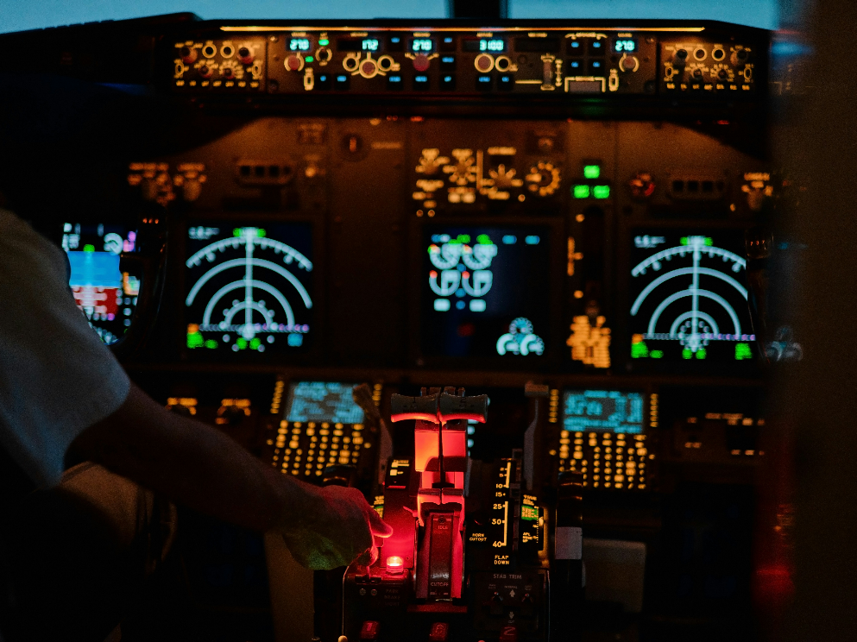

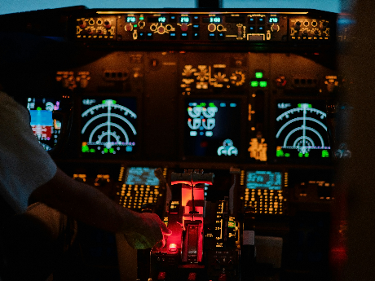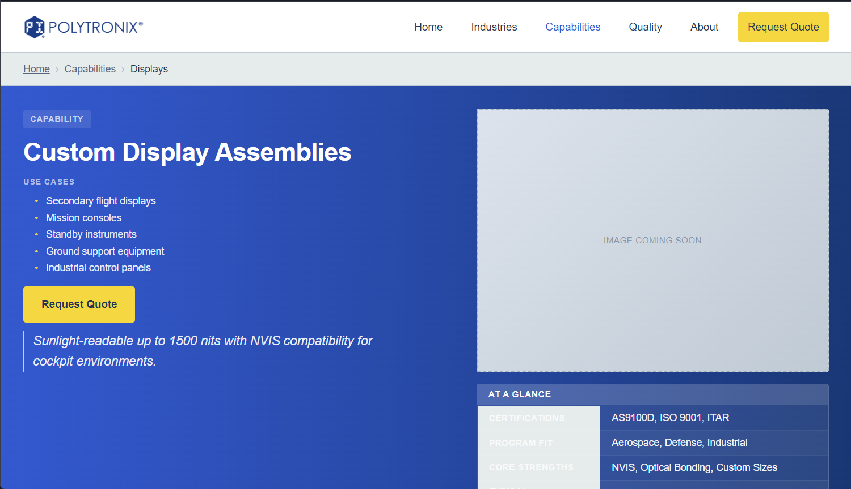

**optical-bonding.html**

**Debugging:** Link should be capabilities/optical-bonding Fix overview

**Placeholder image:**

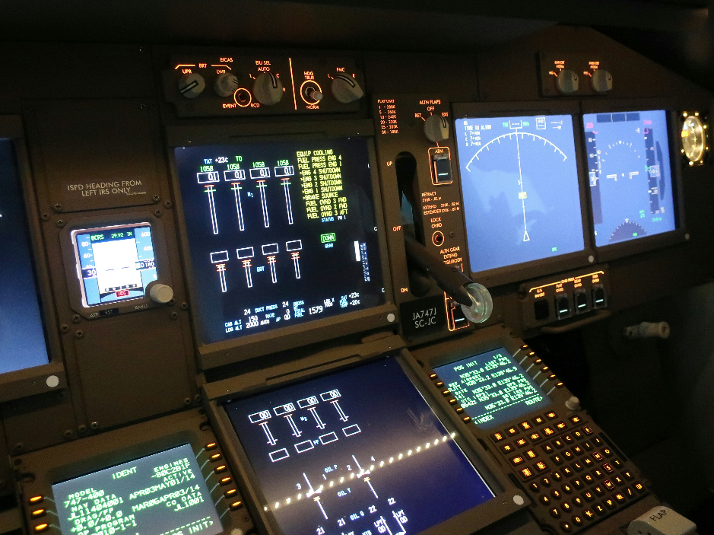

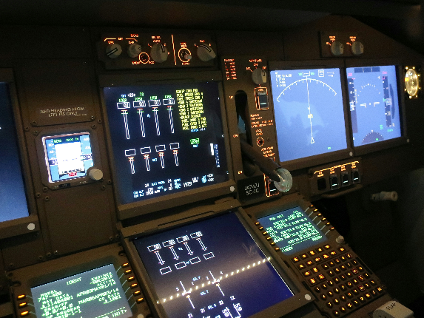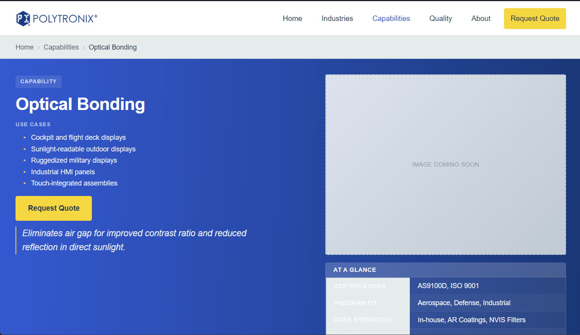

**electro-mechanical-assemblies.html**

**Debugging:** Link should be capabilities/electro-mechanical-assemblies Fix overview

**Placeholder image:**

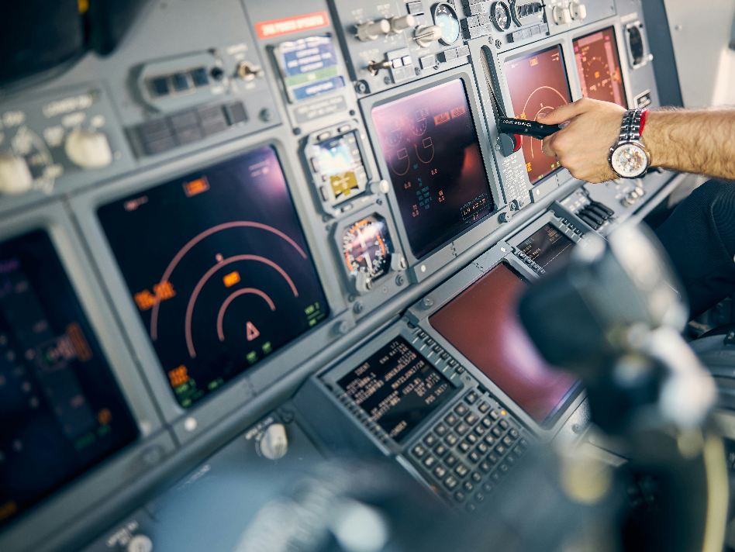

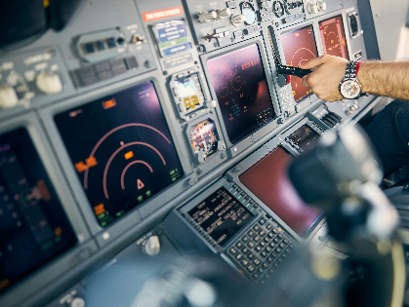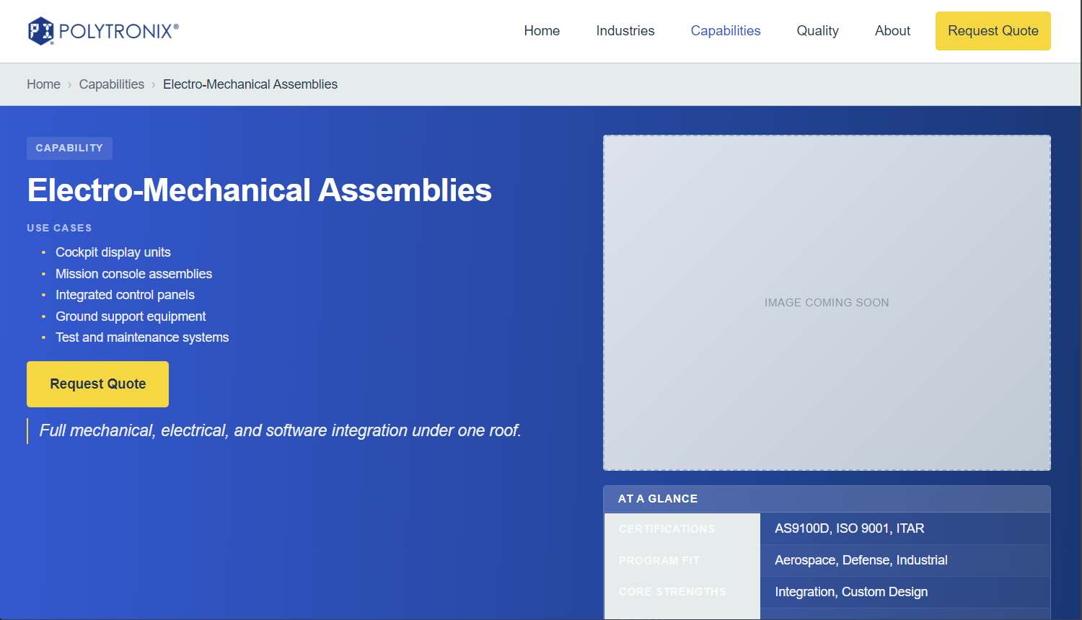

**cable-wire-harnesses.html**

**Debugging:** Link should be capabilities/cable-wire-harnesses Fix overview

**Placeholder image:**

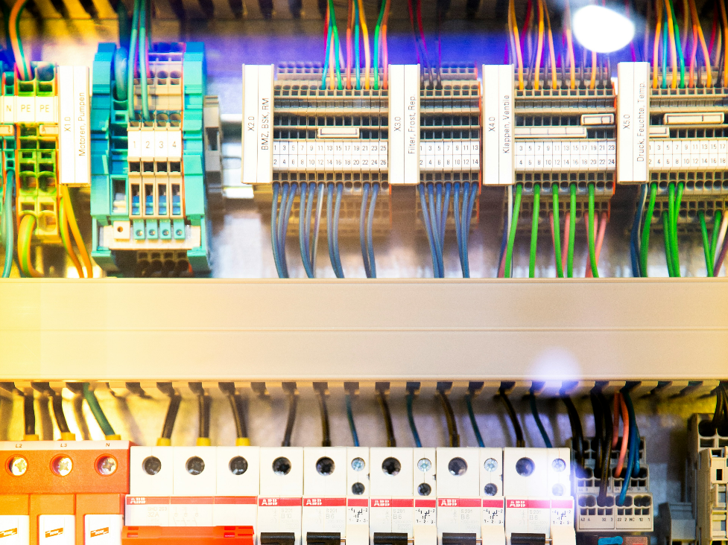

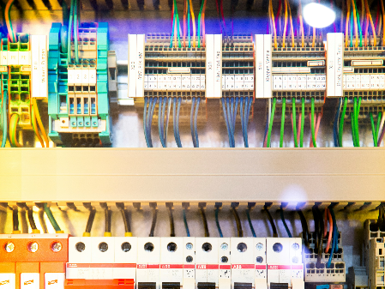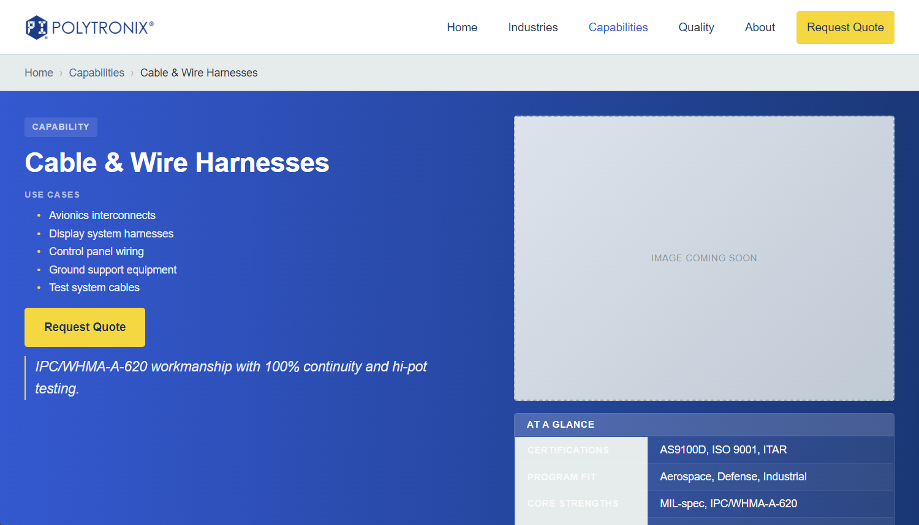

**box-builds.html**

**Debugging:** Link should be /capabilities/box-builds Fix overview

**Placeholder image:**

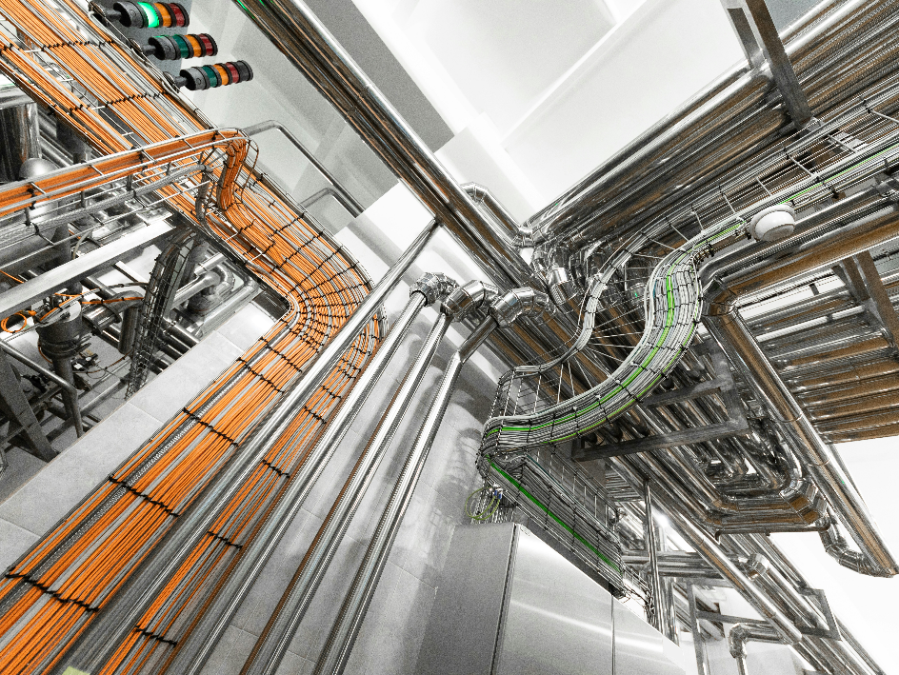

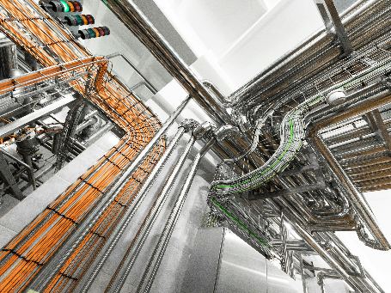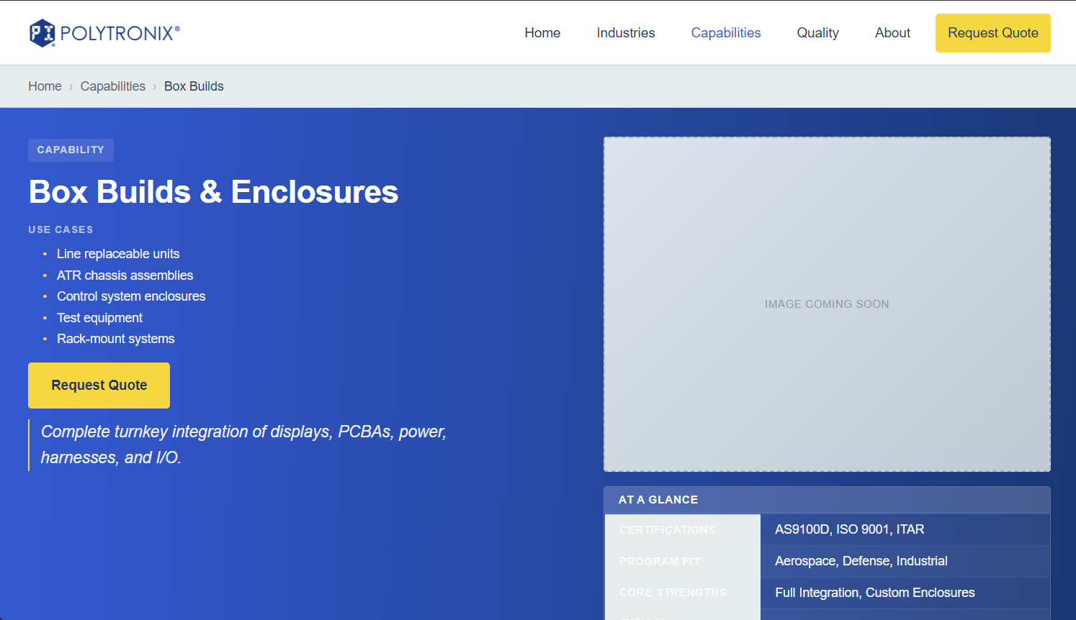

**nvis-solutions.html**

**Debugging:** Link should be capabilities/nvis-solutions Fix overview

**Placeholder image:**

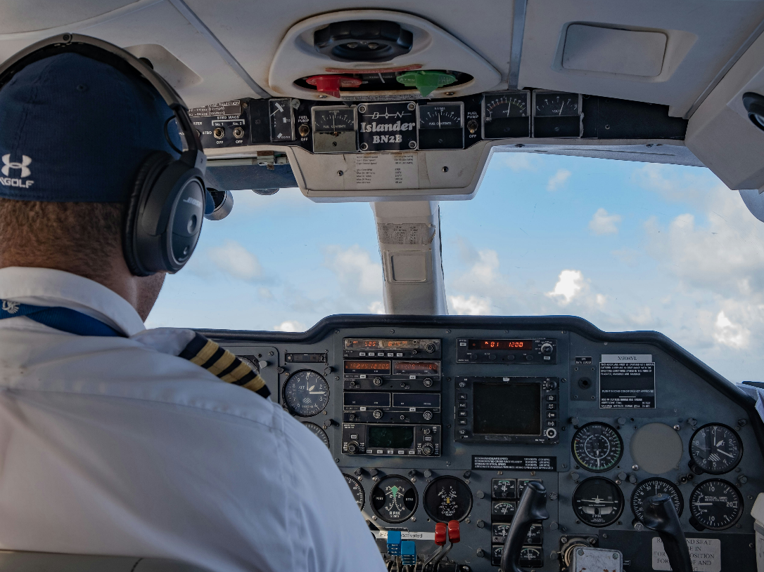

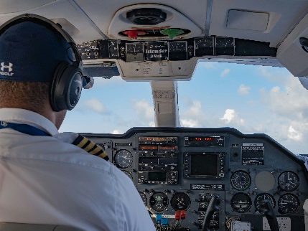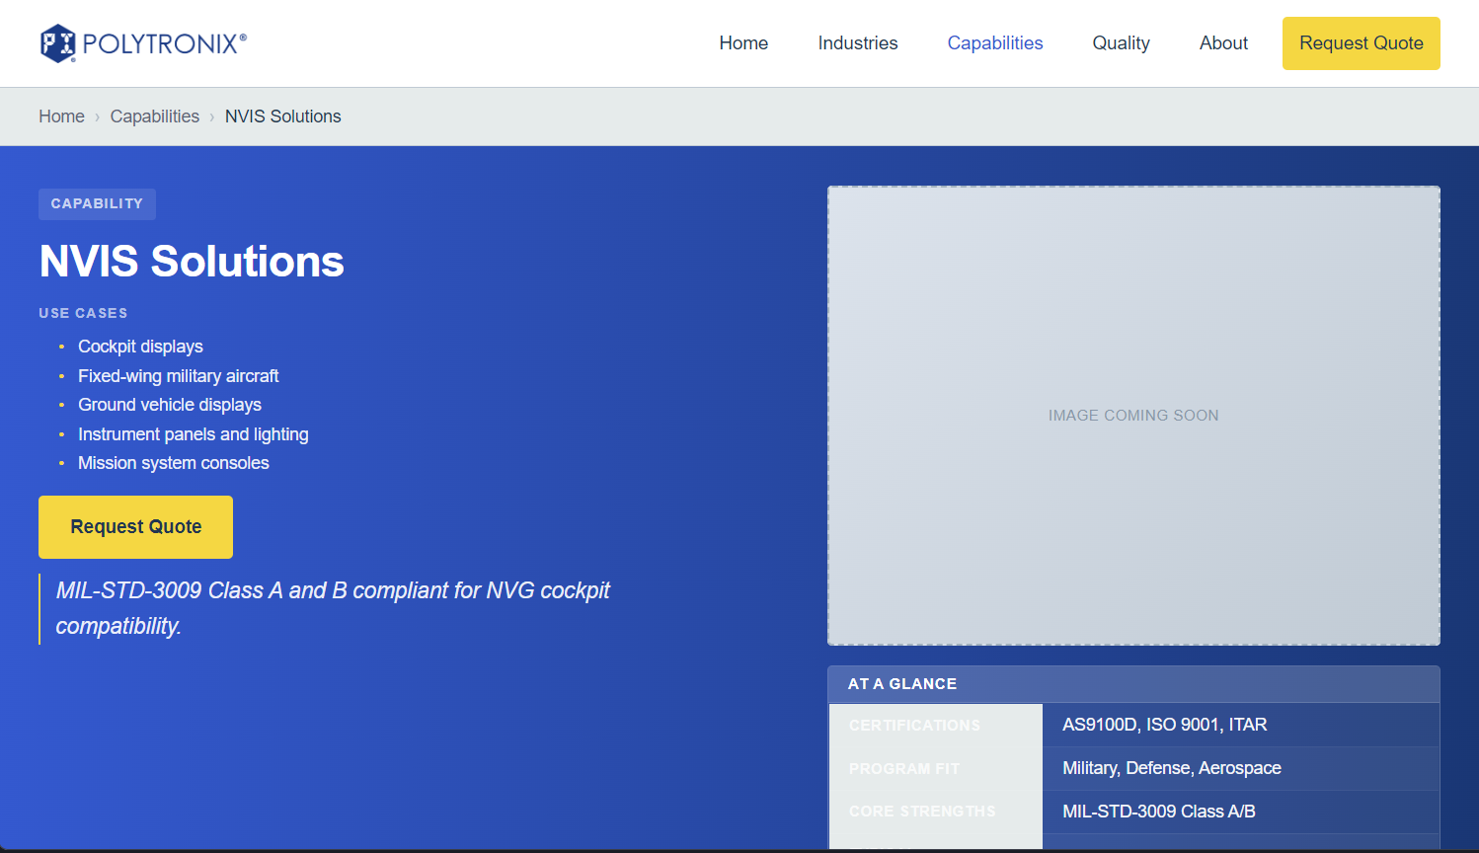

**ruggedization.html**

**Debugging:** Link should be /capabilities/ruggedization Fix overview

**Placeholder image:**

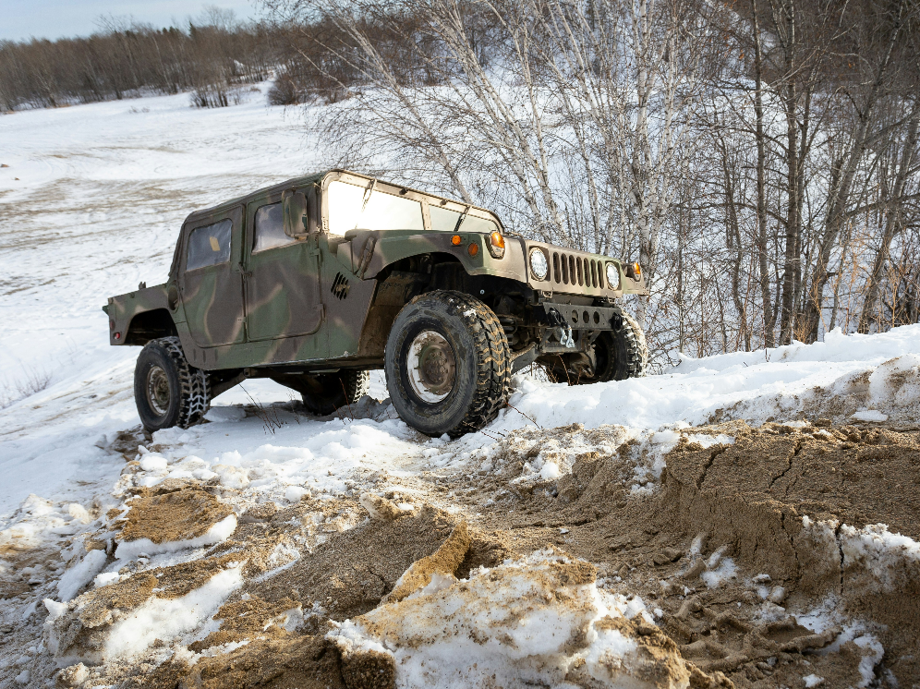

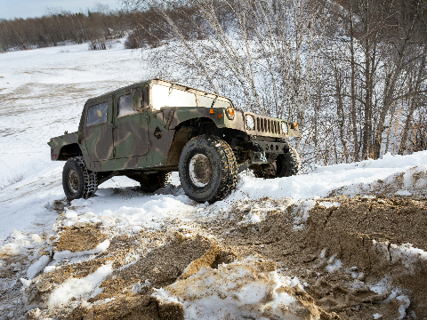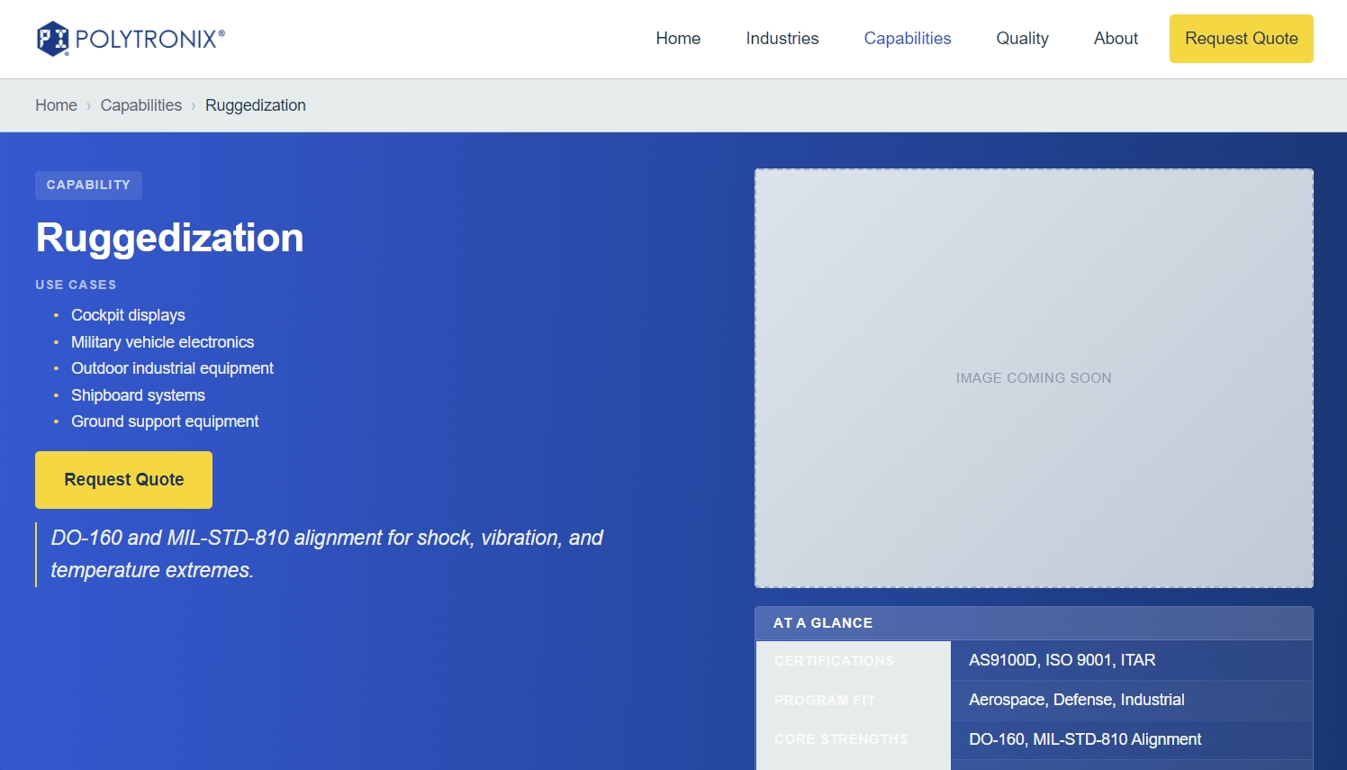

**touch-integration.html**

**Debugging:** Link should be /capabilities/touch-integration Fix overview

**Placeholder image:**

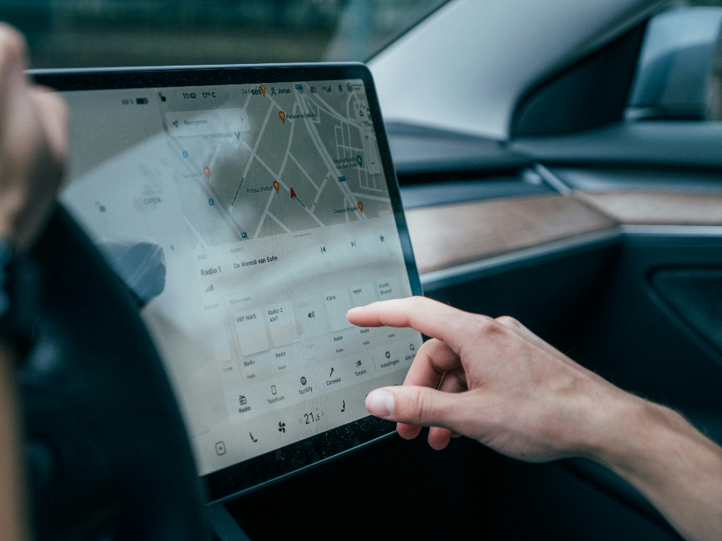

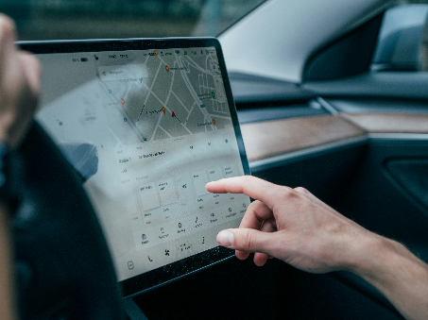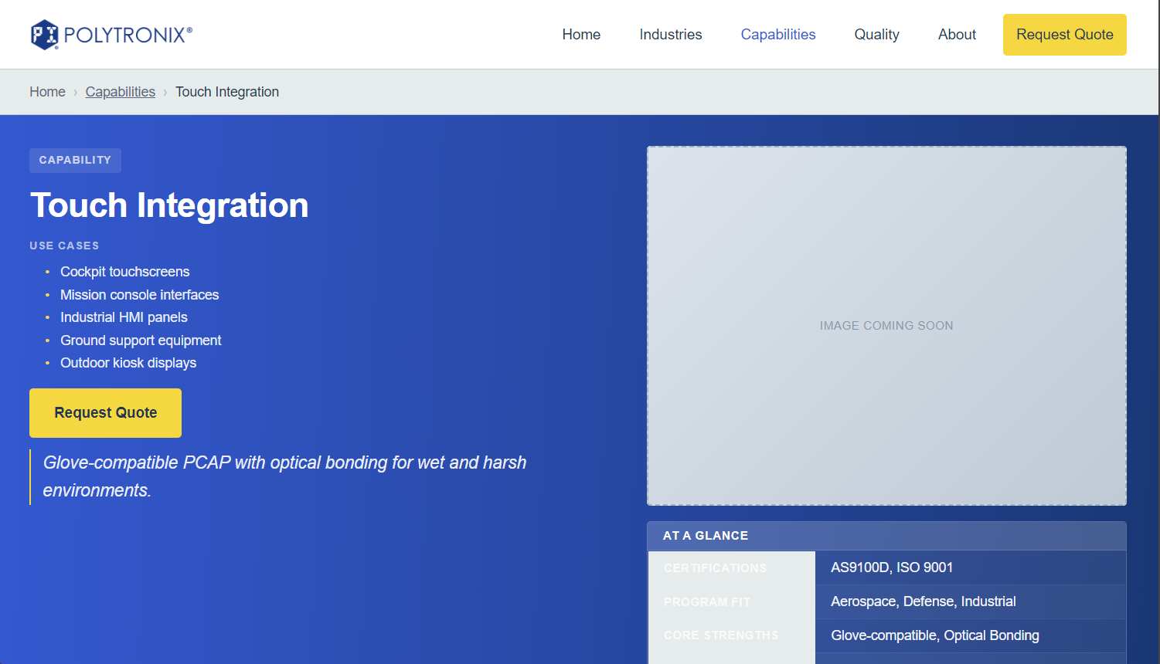

**pcb-assembly.html**

**Debugging:** Button works but Link should be capabilities/pcb-assembly Fix overview

**Placeholder image:**

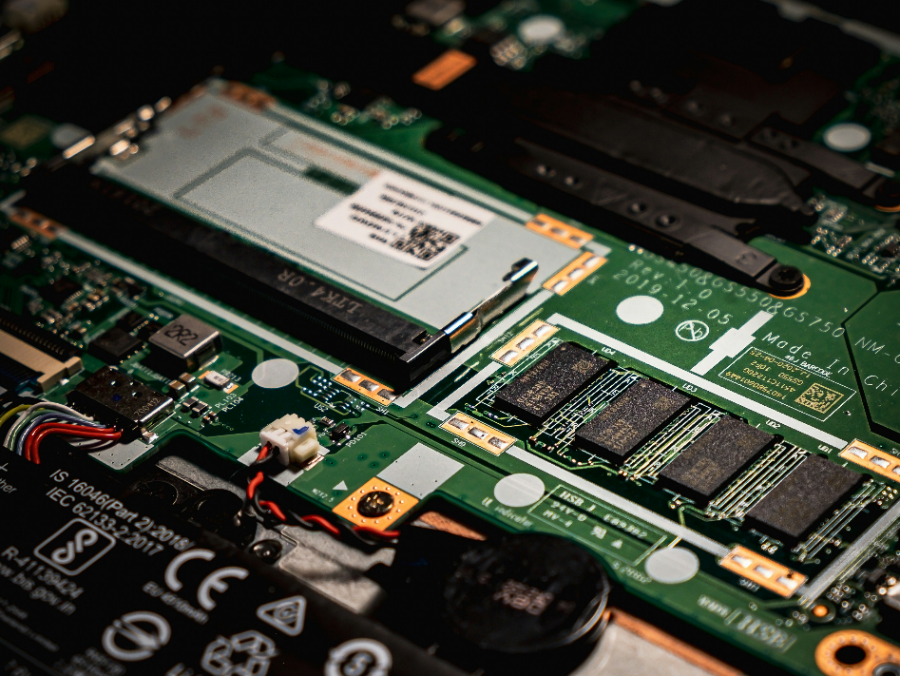

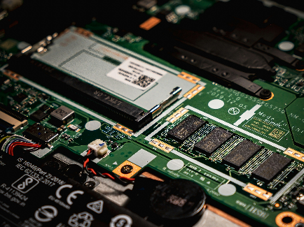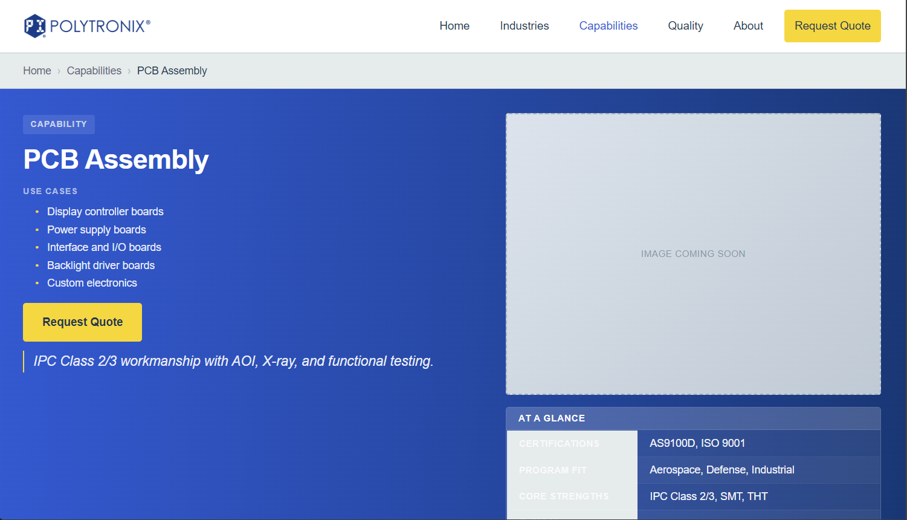

**machining.html**

**Debugging:** Link should be capabilities/machining. Fix overview

**Placeholder image:**

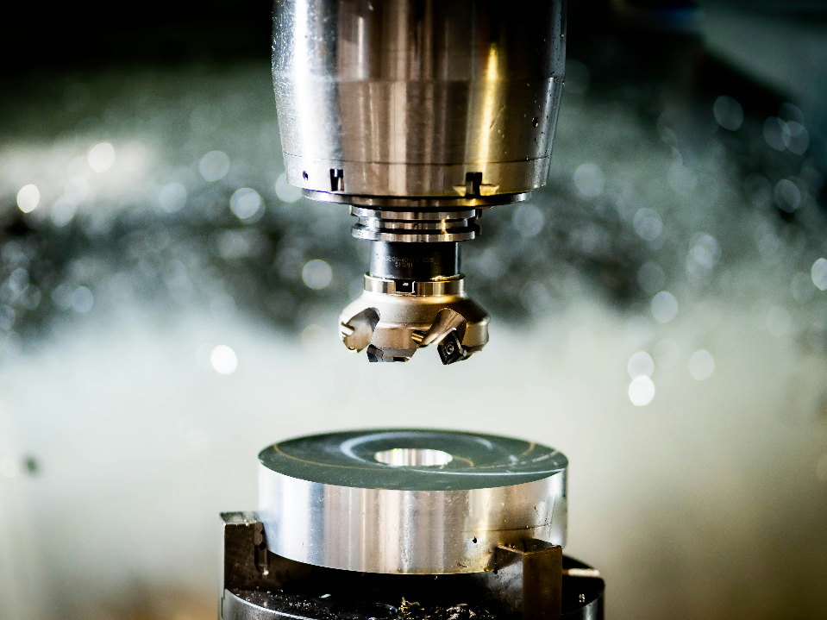

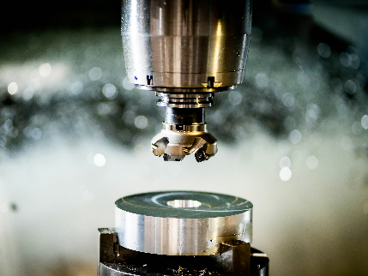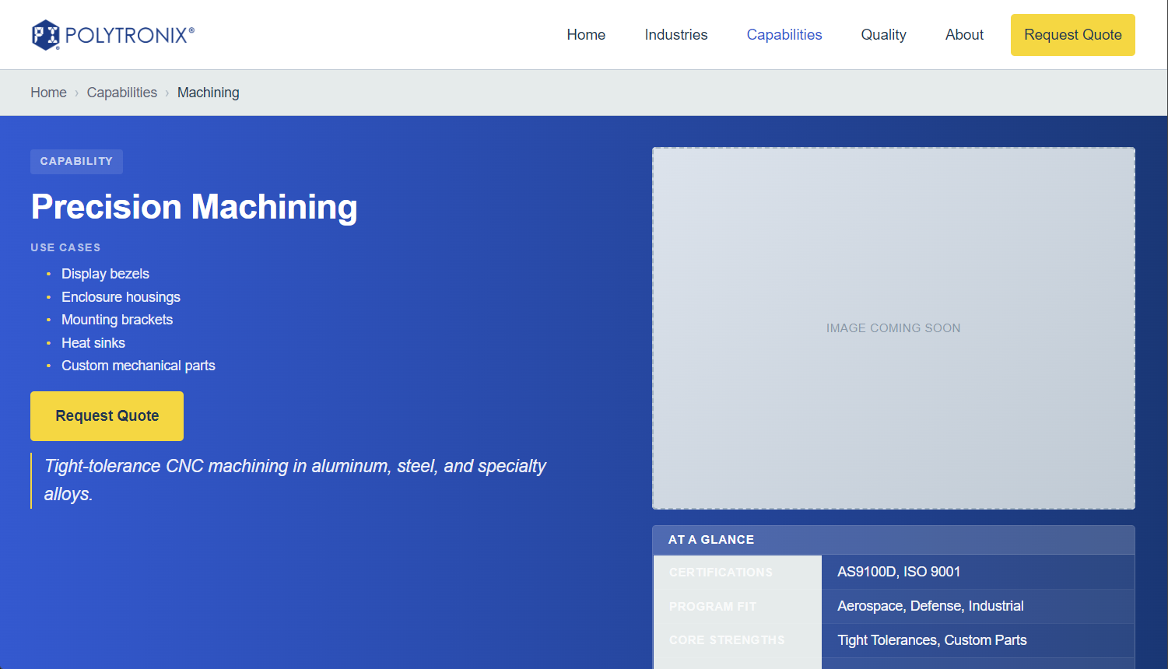

**harness-design.html**

**Debugging:** Link should be /capabilities/harness-design Fix overview

**Placeholder image:**

**Request image from client (of a cable avionics harness or similar)**

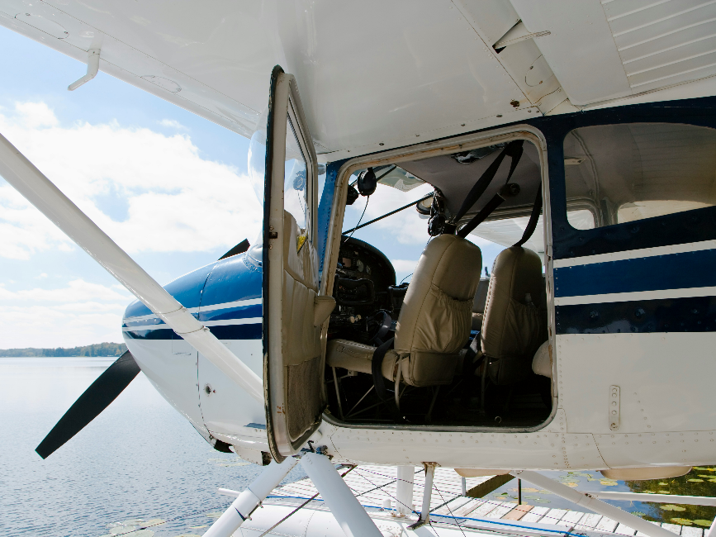

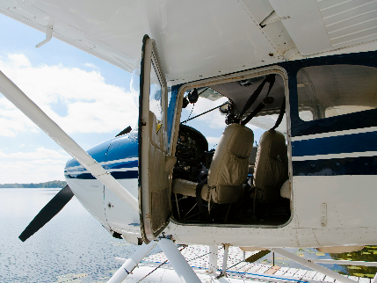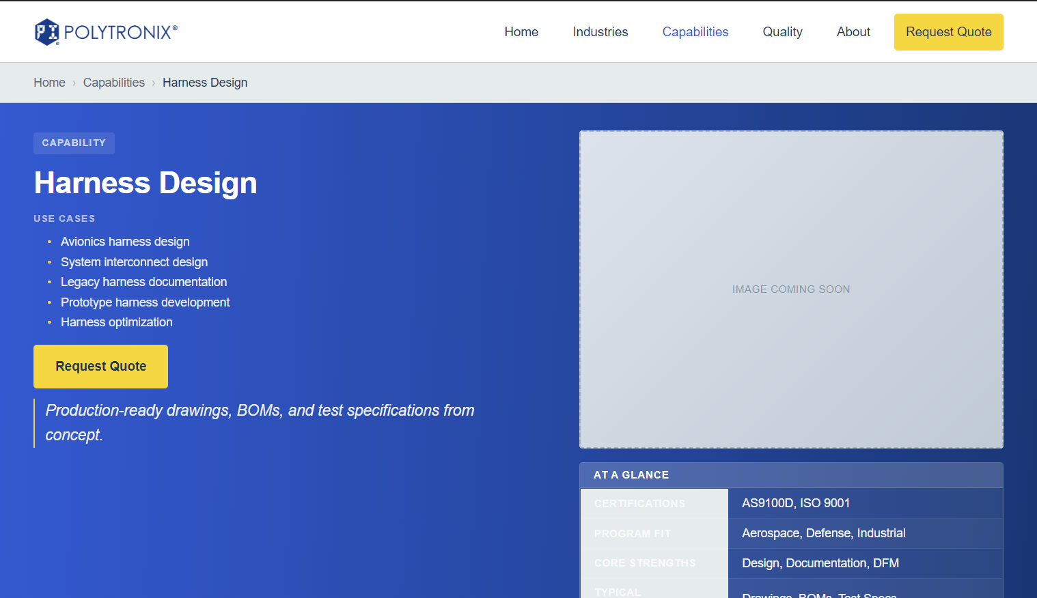

**instrument-lighting.html**

**Debugging:** Link should be capabilities/lighting_placeholder Fix overview

**Placeholder image:**

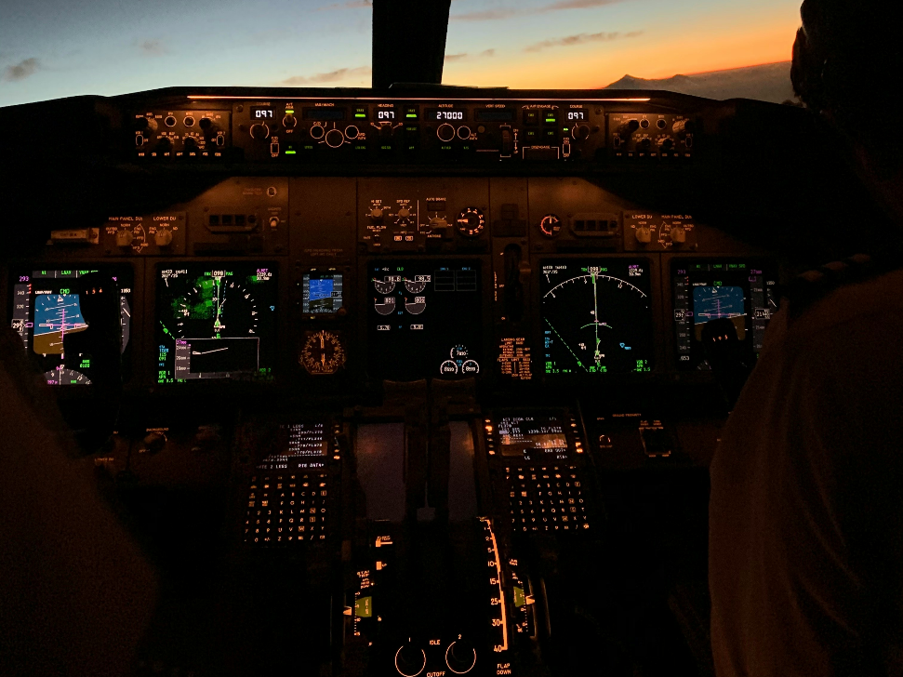

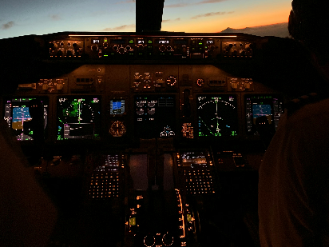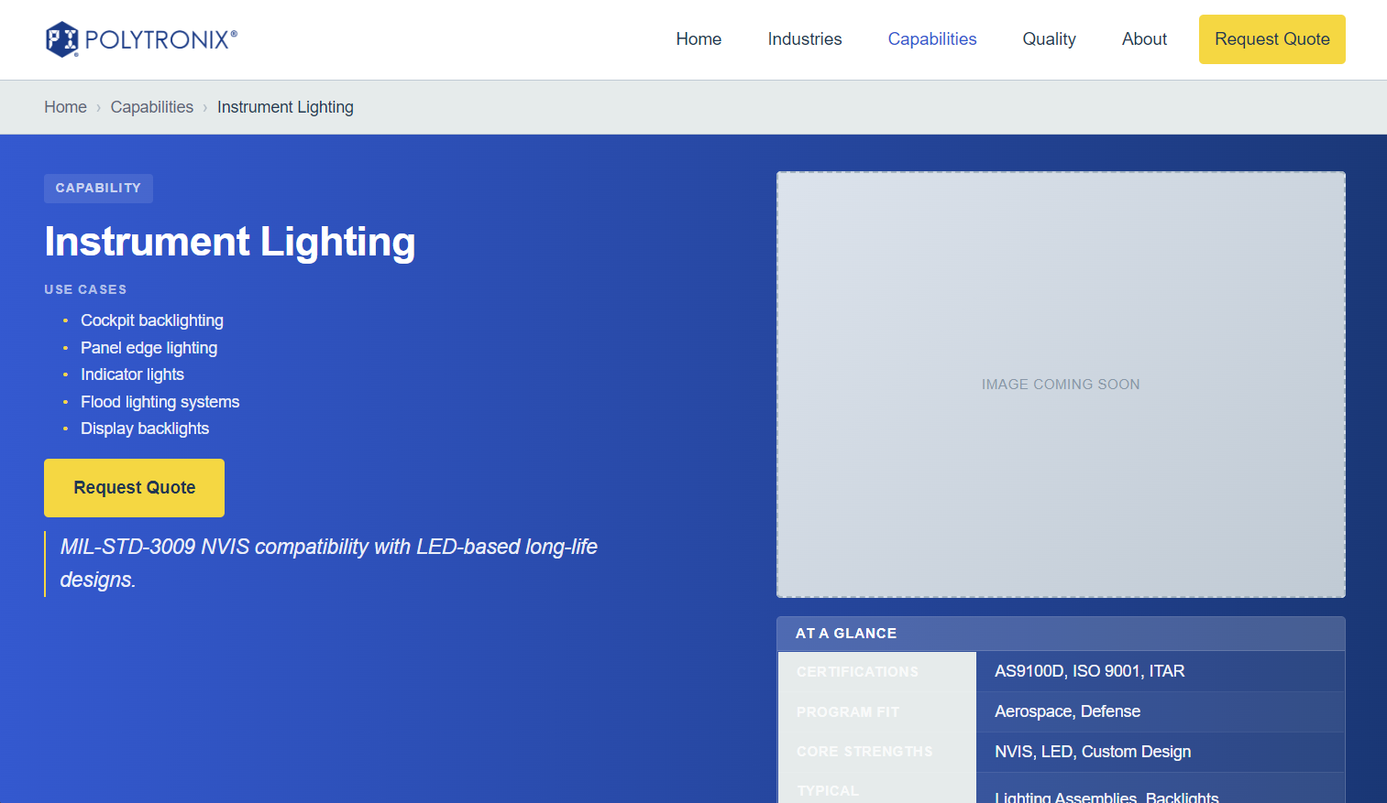

**instrument-panels.html**

**Debugging:** Link should be capabilities/instrument-panels Fix overview

**Placeholder image:**

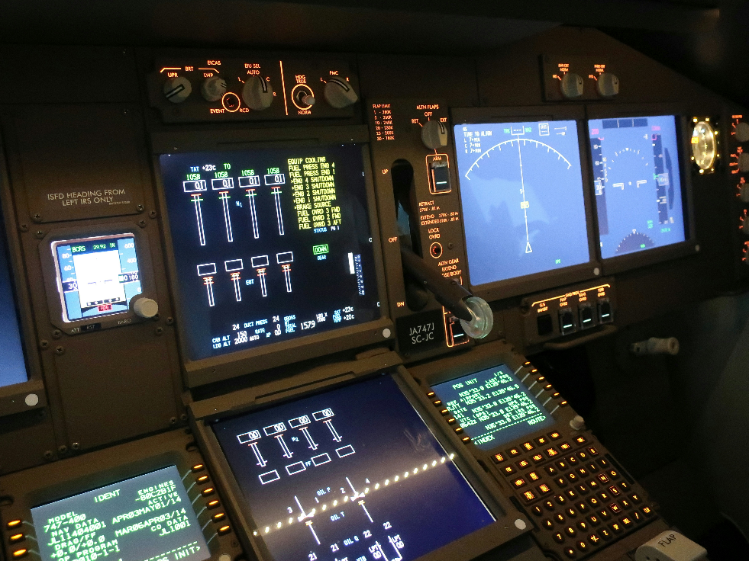

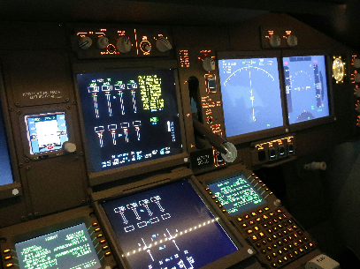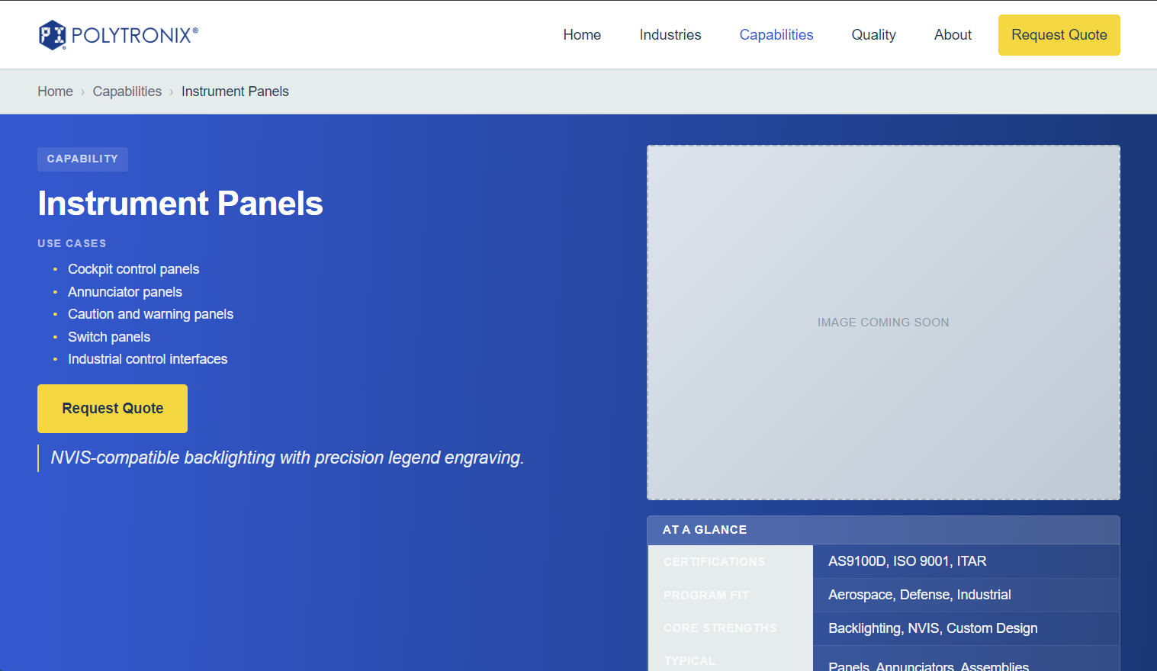

**custom-engineering.html**

**Debugging:** Link should be capabilities/custom-engineering Fix overview

**Placeholder image:**

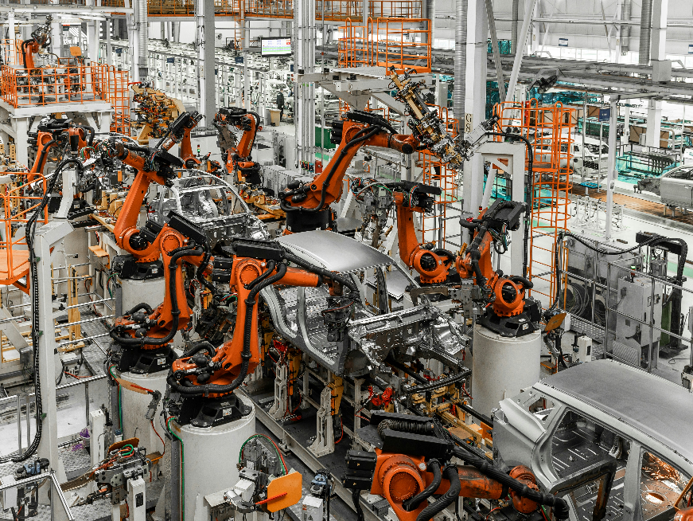

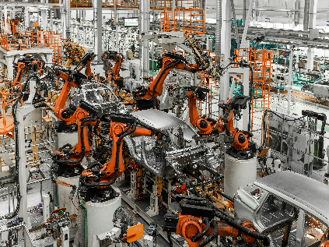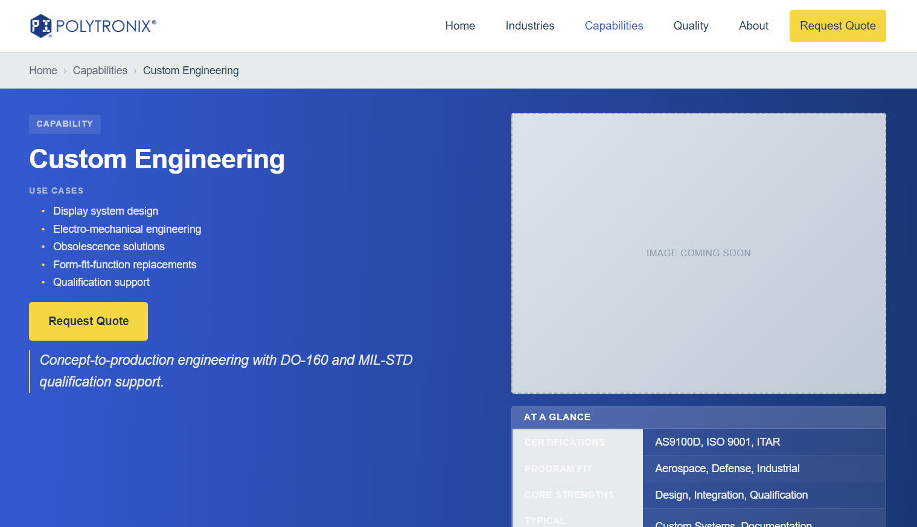

**repair-station.html**

**Debugging:** Link should be capabilities/repair-station Fix overview

**Placeholder image:**

